**Medical Image Processing Tool**

PSD 1 report submitted in partial fulfillment of the

Requirements for the degree of

**Master of Engineering**

**ME (Branch of ME Program)**

by

**<Name>**

(Regd. No)



**MANIPAL SCHOOL OF INFORMATION SCIENCES**

**(A Constituent unit of MAHE, Manipal)**

**MANIPAL SCHOOL OF INFORMATION SCIENCES**

**(A Constituent unit of MAHE, Manipal)**

**CERTIFICATE**

This is to certify that this PSD 1 report titled

**<Title>**

Is a bonafide record of the work done by

**Name**

Reg. No. XXXXXX

In partial fulfillment of the requirements for the award of the degree of **Master of Engineering - ME (Branch of ME Program)** under MAHE, Manipal and the same has not been submitted elsewhere for the award of any other degree. The dissertation does not contain any part / chapter plagiarized from other sources.

Panel member 1:

**Dr/Mr/Mrs. NAME**

Designation

Affiliation

E-mail id

Panel member 2:

**Dr/Mr/Mrs. NAME**

Designation

Affiliation

[E-mail](mailto:sudhakara.upadya@manipal.edu) id

Dr. Keerthana Prasad

Director, Manipal School of Information Sciences

MAHE, Manipal

**Acknowledgement**

It is great pleasure to thank the people behind the success of this PSD 1 activity. I owe my deepest gratitude to all those who guided, inspired, and helped me to complete this project.

I would like to take this opportunity to express my gratitude and heartiest thanks to my panel members, **Prof. Mr xxxxxxxx**, Designation and **Prof. yyyyyyyy** Designation Manipal School of Information Sciences for his inspirational support and guidance throughout my project period.

My heartful gratitude to **Dr Keerthana Prasad** Professor & Director Manipal School of Information Sciences for his full support and encouragement during the PSD 1 activity.

I would like to thank all sources mentioned in the references.

**LIST OF TABLES**

|  |  |  |
| --- | --- | --- |
| **Table No** | **Table Title** | **Page No** |
| 1 | Outline of the Inception v3 module | 45 |
| 2 | Additional dataset used for various calculation in the project | 49 |
| 3 | Inverters Source Key and Power Waste calculated | 59 |
| 4 | Inverter Efficiency with source key | 59 |
| 5 | Comparison of five different CNN architectures considered in this project | 73 |

**LIST OF FIGURES**

|  |  |  |
| --- | --- | --- |
| **Table No** | **Figure Title** | **Page No** |
| 1 | Specification of the company’s product initial discussed | 13 |
| 2 | History of Solar PV Module Prices | 14 |
| 3 | Working and Various equipment’s of Solar PV system [42] | 17 |
| 4 | Partitioning of given data | 21 |
| 5 | Flowchart of Data Pre-processing steps | 21 |
| 6 | One-line diagram of the proposed work for the initial data reived | 22 |
| 7 | Flowchart of the methodology | 23 |
| 8 | Information Transfer [41] | 29 |
| 9 | Gates of LSTM [41] | 30 |
| 10 | Hidden State and cell state [41] | 30 |
| 11 | Working of Random Forest Algorithm [42] | 31 |
| 12 | Basic CNN Architecture [43] | 33 |
| 13 | Skip connection [45] | 35 |
| 14 | ResNet’s Architecture [45] | 36 |
| 15 | Skip connection 3 layers [45] | 36 |
| 16 | Architecture of VGG-16 | 37 |
| 17 | ConvNet Configuration | 39 |
| 18 | Basic Inception module | 41 |
| 19 | Structure of Asymmetric Convolutions | 42 |
| 20 | Two 3×3 convolutional layers | 42 |
| 21 | Utility of Auxiliary classifiers | 43 |
| 22 | Two parallel blocks of convolution and pooling | 44 |
| 23 | final Inception V3 model [46] | 44 |
| 24 | Architect of Efficient-B0 | 46 |
| 25 | EfficientNet Performance | 46 |
| 26 | Parameters of the initially given plant generation data | 48 |
| 27 | Parameters of the initially given plant weather data | 48 |
| 28 | Parameters of the solar pv system given by the company | 48 |
| 29 | Azimuth angle is like a compass direction with North=0° & South= 180° | 50 |
| 30 | AZIMUTHAL ANGLE CALCULATIONS From South side | 50 |
| 31 | Code for Azimuthal Angle | 51 |
| 32 | Azimuthal vs Time of the Day | 51 |
| 33 | Relationship of the Energy Generation and Azimuth angle | 52 |
| 34 | AC power generated (kwh) per day by different Inverters | 53 |
| 35 | Code for calculating the total number of inverters | 53 |
| 36 | variation of Inverter efficiency (%) during the daytime | 53 |
| 37 | Power waste calculated (kwh) per hours for January month | 54 |
| 38 | Carbon saving calculated in (kg) per day for a month | 54 |
| 39 | Code for calculating Power Waste | 55 |
| 40 | Predictions of power waste (kwh) per day for a month | 55 |
| 41 | Total power loss calculated in (Rs) per hour during daytime | 55 |
| 42 | Histogram plot of inverter efficiency | 56 |
| 43 | Code for calculating Inverter Efficiency | 56 |
| 44 | Number of Peak sun hours received per day for one month | 57 |
| 45 | Irradiation kw/m2 received by plant 1 for a month | 57 |
| 46 | Irradiation kw/m2 received by plant 1 for a month | 57 |
| 47 | Ambient temperature in ℃ received by the Plant 1 for a month | 58 |
| 48 | Ambient temperature in ℃ received by the Plant 2 for a month | 58 |
| 49 | Prediction of Power waste w.r.t time | 60 |
| 50 | Random Forest prediction of power waste w.r.t number of days | 61 |
| 51 | Rain fall Prediction for next 15 days | 61 |
| 52 | Energy generation prediction for next 15 days | 61 |
| 53 | Energy Consumption prediction for next 15 days | 62 |
| 54 | EROI prediction for next 15 days | 62 |
| 55 | Block Diagram of Folder Structure | 62 |
| 56 | list of models and their error percentage | 63 |
| 57 | Basic diagram of Resnet | 64 |
| 58 | Architecture of Resnet 50 | 65 |
| 59 | Parameters of Resnet 50 | 65 |
| 60 | Details of the Model training | 65 |
| 61 | Plot of Number of Epochs vs Train Loss & Val Loss | 65 |
| 62 | Saving the model to build flask Application | 66 |
| 63 | Training loss w.r.t number of epochs (VGG 16) | 66 |
| 64 | Efficiency w.r.t number of epochs (VGG 16) | 66 |
| 65 | Training loss w.r.t number of epochs (VGG 19) | 67 |
| 66 | Efficiency w.r.t number of epochs (VGG 19) | 67 |
| 67 | Efficiency and Loss w.r.t number of epochs (EfficientNet-b0) | 68 |
| 68 | learning rate w.r.t number of epochs | 68 |
| 69 | ROC curve for solar panel classification | 69 |
| 70 | Sample Web application Created | 70 |
| 71 | Result Obtained from the Web application Created | 70 |
| 72 | Image no.1 used for testing | 70 |
| 73 | Image no.2 used for testing | 70 |
| 74 | Good clean image used in training the model | 71 |
| 75 | Soiled image used in training the model | 71 |
| 76 | Image no.3 used for testing | 71 |
| 77 | Basic Flask App Created | 72 |
| 78 | Metrics used in the ML Models | 72 |
| 79 | Front page of the web application | 73 |
| 80 | lower part of the front web application | 74 |
| 81 | Different tabs incorporated in the web application | 75 |
| 82 | The sample application proposed is integrated to the main web application | 76 |

**Contents**

|  |  |  |  |  |  |
| --- | --- | --- | --- | --- | --- |
|  | | | | | Page No |
| Acknowledgement | | | |  | i |
| List of Tables | | | |  | ii |
| List of Figures | | | |  | iii |
|  | | | | | |
| **ABSTRACT** | | | | | 1 |
| **Chapter 1** | | | **INTRODUCTION** | | 2 |
|  | 1.1 | Introduction | | | 2 |
|  | 1.2 | Literature review | | | 3 |
|  | 1.3 | Motivation to do the project work | | | 11 |
|  | 1.4 | Objective of the work | | | 12 |
|  | 1.5 | Target Specifications | | | 12 |
|  | 1.6 | Summarized outcome of the literature review | | | 13 |
|  | | | | | |
| **Chapter 2** | | | **BACKGROUND THEORY** | |  |
|  | 2.1 | Introduction | | | 15 |
|  | 2.2 | Introduction to the project title | | | 15 |
|  | 2.3 | Theoretical discussions and General circuit analysis | | | 15 |
|  | 2.4 | Conclusions | | | 16 |
|  | | | | | |
| **Chapter 3** | | | **METHODOLOGY** | |  |
|  | 3.1 | Introduction | | | 18 |
|  | 3.2 | Proposed Methodology | | | 18 |
|  | 3.3 | Data Pre-processing Steps considered for developing ML models | | | 19 |
|  | 3.4 | List of steps conducted in the project to achieve the objective | | | 20 |
|  | 3.5 | Key Performance Indicator-(KPI): | | | 24 |
|  | 3.6 | Tools used | | | 25 |
|  | 3.7 | Formulas used for calculation | | | 25 |
|  | 3.8 | Conclusion | | | 47 |
|  | | | | | |
| **Chapter 4** | | | **RESULT ANALYSIS** | |  |
|  | 4.1 | Introduction | | | 48 |
|  | 4.2 | Dataset Analysis | | | 48 |
|  | 4.3 | Result analysis | | | 49 |
|  | 4.4 | Sample Web application Created | | | 69 |
|  | 4.5 | Adam Optimizer Gradient Descent | | | 71 |
|  | 4.6 | Significance of The Results and conclusions | | | 72 |
|  | | | | | |
| **Chapter 5** | | | **CONCLUSIONS & FUTURE SCOPE** | |  |
|  | 5.1 | Conclusions | | | 76 |
|  | 5.2 | Future scope of work | | | 77 |
|  | | | | | |
| **REFERENCES** | | | | | 78 |

**Abstract**

Solar is the most abundant source of energy on earth for humankind. By knowing that non-renewable resources are getting reduced day by day and the concern on the rapidly changing climate due to the increase in carbon emission, there is increase in the development of renewable energy sector. The project outlines an understanding of how AI can identify the problems and could rectify within minimum time interval. Research in this field has only concentrated on a single parameters like weather forecasting, power output forecasting, module performance and data acquisition.

The objective of the project is evaluation of solar PV system’s performance by developing a web application which includes different ML modules to create a visual dashboard for various solar pv parameters data. The methodology adopted is all about how AI application could help in evaluating the performance of PV system. The software tools used in this project are python, Microsoft excel, google colab, Jupyter-notebook and machine learning models.

Energy with AI helps the consumer to understand a detailed information of the performance of the power plant by collecting the various data of different parameters that could enhance the performance and produce more output. Not only the generation can be forecasted but also the load management, plant operation and maintenance can be done without any Human intervention. In this project we are not specified on a single set of parameters but covering all the parameters considers for improving the plant performance right from the installation to the plant operation and maintenance.

The solar pv plant dataset given by the company was processed and analysed the data into visual dashboards with the help of interactive and intuitive machine learning models using Jupyter-notebook with the help of python. Few parameters of solar pv system are predicted with the help of different ML models like LSTM, Random Forest, Arima and linear regression models. By using CNN architecture images of different solar modules are analysed and where able to identify whether the solar module images are soiled dust accumulated modules/clean good modules which is one of the major reasons for low power generation of pv system. The deep learning models used for image processing are Resnet 50, VGG 16, VGG 19, Inception v3 & EfficientNet-B0.

**Chapter 1**

**Introduction**

**1.1 Introduction**

The Present-day development of different sectors incorporated in the research study and how important is renewable resources for humankind in recent times is discussed. The overall discussion shows that the project research study is to work towards sustainability. This also includes the discussion about the recent research work of solar PV system and their outcomes. A list of objectives and expected outcomes are listed.

Solar PV system is the easiest and cheapest way of producing electricity commercially for large- and small-scale sectors [1], [2]. Renewable energy sector has reached to the place of importance in the current world scenario. Artificial Intelligence plays an important role in the modern world, and its application has been applied in all the sectors special in Energy sector nowadays [3], [4]. With the help of data analytics, it becomes easier to identify the basic decision-making ability in the field of renewable energy sector. Since the operation and maintenance of the renewable energy system has not fully incorporated with the modern technologies available in the present world, utilization of different methodologies is incorporated in this research work considered by the solar industry to operate the system efficiently. The Renewable energy system has a lot of data being logged and data analytics is applied for the dataset to derive more profitable outcomes in terms of ROI and energy as well.

The purpose of this project is to extract useful information from the data collected and consider the operating decisions based on the outcome of the analysis. More importance is given for implementation of human intelligence in the data management, operation, and maintenance of the solar photovoltaic power plants. To extract the useful information, different machine learning models are incorporated which included different mathematical concepts. Currently INDIA is in the fourth position for installed renewable energy capacity globally and has a 39% of share in the total installed Electricity Generation capacity in the country [5]. INDIA’s solar capacity has increased more than 49 $Gw$ from 2.6 $Gw$ in the past seven years and has a share of 12.73% of overall energy capacity in INDIA [6]. INDIA has a bigger target of achieving Net -Zero emission by the year 2070 [7] and a large Renewable Energy expansion target of achieving 500 $Gw$ of installed capacity non-fossil energy by the year 2030.

**1.2 Literature review**

The discussion on reducing the human intervention in a solar PV plant made authors of [8] to come up with a model that does not require high budget or licensed software for collecting various parameters to achieve a system performance remotely. With the help of data gathering there are many advantages, and few are explained in this paper. The authors presented an efficient & inexpensive IoT established data acquisition system with the help of free access software including cloud service which collected more than eight different parameters of photovoltaic system. The proposed model was tested on a single PV module but, implementation on small scale and industry standards are yet to be explored.

As compared to the previous review paper an online Realtime inexpensive monitoring system first of its kind is proposed in [9], for the domestic solar photovoltaic system with the help of Internet of Things (IoT) technology. As there are many online monitoring projects established the authors gives a clear idea of what different are they going to present in this paper and with the help of IoT the authors verified some of the function of MPPT which are used presently. With the help of MATLAB/Simulink software the authors incorporated five MPPTs algorithms for the user’s choice of two inputs and twenty-five rules, where the inputs are the power and voltage. By comparing the different MPPT algorithms authors concluded that fuzzy logic MPPT is the best suitable in terms of efficiency, convergence time, and cost effectively.

An improved autonomous remotely observing system is proposed by the authors of [10], for Grid tied photovoltaic System with help of LabVIEW and Data acquisition. The authors have gone through a larger number of distinct papers which consist of a variety of approach, software, component, and method applied in PV system which helped in listing several problems that are being faced by the existing monitoring systems. The overall model proposed consist of real time visual dashboard consisting of several tabs of functioning the different sectors in system with help of LabVIEW and main objective was the recommended Photovoltaic backup storage system with three different functionality power producing source from a battery, Photovoltaic with battery, or only Photovoltaic. Even charge status, consumed power and discharged power by the battery is also measured and the power drawn from the PV to array include MPPT charge controller and even the data time interval can be changed.

A discussion about undetected faults happening in the solar PV system is done by the authors of [11], by reviewing recent papers with the help of AI & IoT for checking the performance of the plant from a remoted place, error detection and analysis of PV system. Algorithm used are superior algorithms such as ML & DL, considering in terms of expense, complication, accuracy, practicality, and software suitability for present time applications. Authors gives a brief description of available technics, faults, commercial equipment, and its application in real time for analysis and diagnose. The fault analysis is divided into three dissimilar categories and explains the lack of performance using the commercially equipment by giving the reason for the use of AI and its research gap.

The discussion on the sudden increase in need for different online monitoring PV system can be found in [12], and its insecurities are also explained. Authors investigates in detail about the different data acquisition modules & data transmission procedures by classifying into dissimilar categories. This paper contains all the required information for future research works which includes challenges and reviews for enhancement in the field of PV monitoring technologies for various PV application.

A new novel approach for selecting an appropriate site for solar Photovoltaic system is presented in [13], with support of analytical hierarchy practice & density established clustering. The use of MCDM-GIS methodology was common in this research field, but the exception was that they all considered a very few criteria while site selection. The authors give a list of different processes carried out from the traditional method. The authors consider the process to be conducted in 5 phases which contained a larger portion for safety and is a complex process hence requires more time than the regular methods.

As a continuation on the topic of site selection for PV system [14] discuses about the estimation of the solar energy generation potential with the help of multi-criteria decision analysis (MCDA) using geospatial technologies. The method used in this paper is preparing a map that contains the region suitable for solar power plants where they extract the direct normal irradiance from images obtained from the satellite and develop a model out of it. The authors summarise the literature reviews considered in the paper and conclude the main or important criteria for selection of suitable area.

A need for research in site selection is explained by the authors of the paper [15]. The authors used a combination of geographic information structure established by multi functioning decision making for creating a spatial outlay in-between Suitability map & Electric load density map with the viewpoint of suitability and the necessity of energy supply from distributed generation. After creating the overlay map, the final detailed map that has located the suitable site is done with the help of established parameter D which consists of High voltage/Medium voltage substations and medium voltage feeders. Authors share their opinion on the literature saying that more than 75% of the studies conducted had some issue with grid tied Photovoltaic systems and work that aimed on obtaining a suitable photovoltaic map did not considering the present/upcoming electric load demand. Authors use the absolute method in selecting the correct place with weighted linear combination and load density maps, later with the help of it spatial overlay is applied finely to get a raster map with 100 m × 100 m resolution.

A functional analysis of 100 $kWp$ solar Photovoltaic system is conducted in [16] considering geographical location, system design, selection of components selection, annual solar insolation, sizing, panel facing direction, losses analysis, functioning, and energy output. Authors give a detailed information of what are the components and specification related to different parameters. The authors also describe different losses that could occur and overall, the performance was classified into energy produced, performance ratio, losses in system. One can get to know the approximate details of what the best fit components and other parameters value could be to get the PV system work in superior performance with help of this project. It would have been better if the authors could have explained about the finance part related to return of investment, operation cost, etc.

Three different objectives are established in [17] and the authors tried and accomplishes it and has produced idea of finding various curve fitting approaches using MATLAB. To find generation capability of the power plant the authors has produced the different method by using CUF, by estimating different parameters the authors considered Genetic Algorithms to incorporate all the parameters to achieve goals of minimizing the generation & demand gap and to estimate the solar PV plant size. The data set used to identify the outcomes was very less and the authors lacked in getting few data set to accomplish accurate results.

A GIS with AHP (MCDM methods) is used to generate the map with the help of methodological framework that contains the suitable information that makes the policy makers and investors to implement solar projects is carried out in [18]. For the collected data seven different criteria were selected and for developing solar irradiance map five unique steps were carried out. Considering to other research studies, the authors speak about different raster resolution (92m, 250m, 500m, 1000m) with three different scenarios AHP, equal weight and higher economic. All thought there are few research paper considered 1km raster resolution, but they lack a proper explanation so considering it, this study is better which is carried out for four different raster resolution. The authors suggested the optimal choice that is raster resolution of 92 m for site selection of grid tied large scale system. The authors not only explain how to calculate average annual of GHI but also gave an equation to calculate annual solar power generation capacity, where for Algerian in 2018 it was 76,017 $GWh$.

A unique technique called Technique for Order of Preference by Similarity to Ideal Solution (TOPSIS) to identify the suitable sites for installation of solar projects is proposed by the authors of [19] considering the current growth and improvements in renewable energy sector in India to help the cities to reach out their missions. Authors explains how the previous papers were not able to determine the optimum generation of electricity through renewable resources varying over space & time and also discussed about additional point of considering the importance of power backup storage system for solar photovoltaic systems. The method conducted considered a lot of procedures in which the economically feasible zones were classified with the help of four dissimilar categories. The authors did not discuss on considering any specific location but, overview of whole India was explained considering it by cities wise, but the authors gave an exceptionally good literature reviews with the drawback mentioned in it.

A segment of separating or identifying Photovoltaic System by using spatial resolutions images taken from satellite and aerial position which is from an open-source data site is proposed in paper [20]. The Authors built different models of distinct deep networks which does only one work that is segmenting PV panels for a given image and has listed which model would be perfect for which type of image which contains different background portion. But the outcome of the segmenting is not justified and including to that the authors has added some future scope considered the data the used on his paper.

A lifetime yield of solar PV system is predicted by giving importance to Degradation rate $(R_{D})$ and in improving the reliability of the system even though there is no standardized method to calculate the accurate $R_{D}$ value. The authors discuss about the impact of Time portion and dates missing by analyzing, comparing side by side the performance of distinct techniques utilized to synthetical photovoltaic system data at various linear $R_{D}$ samples considering the quantified performing time series and assumed linearity. Since the real value of $R_{D}$ unknow the precision of different methods applied was not considered and by knowing that there is no standardized method followed the authors adds to the interpretation of guidelines for numerous statistical/comparative deprivation techniques beneath noisy conditions. For analysis purpose the authors divided the process into different steps considering the availability of the data and dataset duration. The synthetic data used was gained by ten-year cycle on a single monocrystalline Si PV system.

a real time Data Acquisition System is developed by authors of [21], which can store voltage and current data values in external micro-SD card for the solar PV system in various condition. The hardware is validated for the system reliability and accuracy by doing simulation in MATLAB/Simulink. With the help of the collected data the PV system characteristics are developed, but the system considered was exceedingly small & fewer parameters were extracted.

The applications of PV system in agriculture field considering the increase in the energy consumption due to the use of modern equipment’s is explained in [22]. Here the authors proposed a model named I-solar in MATLAB for optimization of PV system in real time considering the high variability of meteorological conditions and the energy demand. The model was implemented on solar pumping system and was compared with two models in which one of them is simplified and another model created by authors itself using machine learning which didn’t required to determine the irradiance whose surface is inclined, whereas the I-solar model needed it. The ability of the proposed model ware explained and are validated using the theoretical formulas some of which were considered from other papers. With the help of the proposed model one can identify optimal, technical, and economic requirements of solar photovoltaic installations.

An alternate for the conventional method of using solar map despite that the technology that are being used in the present world is proposed in [23]. The author uses microcontroller circuit to extract different parameters which include the solar panel temperature & solar irradiance which could be used as the substitute of the solar map. The author was successful in extracting the data & displaying it in the LCD display and listed that by using that data one could predict the performance of the solar PV system and other activities.

A smart prototype online monitoring of PV system which is also accessible in a website created by the authors of [24] which collects few parameters only. The authors also propose a future implementation which would need a fault detecting algorithm for identify the faults and analysis. Authors gives the details of the advantages of using IoT, here the authors used Raspberry PI and Think Speak of MathWorks for preemptive maintenance, historic analysis of solar PV plant, the fault detection & real time observation by recording video for analysis.

An improved Solar PV output generation forecasting with the help of stacked ensemble algorithm in [25] utilizing 2 deep learning algorithms as a base model and predictions from these models are incorporated using an excessive gradient boosting algorithm to improve the accuracy of forecast and is compared it with other 3 different previously available algorithm using 4 different datasets. The Authors has considered all the recent research and has overcome their limitation by combining two different models and summarizes that the proposed model is the suitable combination of reliability and stability when compared to individual handled models. The authors concluded by giving the suggestions for solar forecasting research and forthcoming work.

The effect of temperature on single phase photovoltaic inverters conversion efficiency [26], considering a rooftop solar system for a data one year. The authors mention that the data logger is also important and to identify the uncertainty of data the authors has come up with a validation for working process of Datalogger. The relation between Module temperature, Inverter temperature & Ambient temperature was discussed and explained what the parameters are to be considered for calculation. The authors divide the yearly data into four quarterly dataset and gives explanation on each one of it. Mentions the section when the inverter could go unbalanced in converting the DC to AC by naming the percentage loss for degree Celsius of temperature increased. Finally, the authors list down the ideas to be followed to reduce the temperature derating of the inverter.

Studies about regression model of solar power generation of utility scale photovoltaic power plant in a hot/humid region for different weather seasons is analyzed and created in [27] utilizing different weather parameters which helps in understanding the potential of the power plant. The authors summarize that outcome by making key points from the analysis done during the experiment few of them were like the solar power generation are affected during the monsoons, generation of the PV plant strictly follows the irradiance pattern (tilted and horizontal), higher generation in low atmospheric pressure in tropical region. Authors also created a model which predicts the optimum generation with the help of regression modelling in Minitab software considering different parameters for 2MWp (peak power of a PV system) power plant.

A study on designing a single-phase rooftop solar PV model with the output terminal of inverter being synchronized with Voltage & frequency of the grid with the help of Hysteresis current loop in MATLAB Simulink is in [28]. The authors mention the possible issues that could happen and listed out the solution for it. The model that authors designed undergoes various test condition and is evaluated in term by comparing it to different parameters. The result of all the novel ides in the paper was satisfactory as the same was expressed by the authors and mention flow of how they are not able to evaluate the performance using material Science.

Studies about experimenting the impact of variation in the tilt angle, solar irradiation in different condition, setups to investigate on the performance and electrical parameters is carried out. Authors conducted two different experimental model one is keeping the tilt angle constant and varying the irradiance and the other is varying the tilt angle for constant irradiance in two places indoor, outdoor. The result showed that the tilt angle and irradiation is indirectly proportional. The efficiency drops and temperature drop was calculated with increase in tilt angle. The increase in temperature is also calculated for increase in irradiance. Optimal tilt angle was generated with the help of the model created in [29].

Studies about finding the efficiency of the solar Inverter was more interesting for the authors, which helped in operation and maintaining of the power plant. To get the more accurate efficiency value of the inverter authors estimated the power generation using the environmental sensers and a linear regression model was built considering the specification of the inverter used in the experiment which helps in identifying the power plant efficiency unites in real time to the plant observer [30].

The performance of the solar module considering the orientation and tilt angle as important parameter was identified to get maximum generation of solar energy with different case studies. Authors proposes a s artificial bee algorithm model to identify the optimal tilt angle. By varying the solar module in horizontal east west direction by an angle of 20 $°$ to 30 $°$ tiltangle. By the incorporating the Perturb & Observe method a comparative study in generating average solar energy with help of optimal tilt-angle. The P and O model is more efficient in computing monthly average solar power and authors concluded that ambient temperature & solar tilt angle are two important parameters to be considered for evaluating PV module output in [31].

A study of a model that generates daily, monthly and energy yield of a specific power plant based on actual environmental condition considering few parameters on the Flat and Tilted Surface is discussed. Authors also explains how important is finding the energy yield instead of the efficiency and the benefits of calculating the energy yield. Here the authors are not only interested in calculating the energy yield of the commercial panels but also for tandem solar cells which are multijunction soler cells [32].

An impact of the windspeed and wind direction on the photovoltaic Power Production is experimented in [33]. The proposed method of a lead filter was included to the PI controller which gives smooth output and high-accuracy performance by acting as a low pass filter. Various wind speed & direction shows variation in the broad range on current & voltage (I-V) and power & voltage (P-V) chrematistics of photovoltaic module. The proposed system was validated by creating mathematical model of PV, DC to DC controller & converter using MATLAB/Simulink and summarizes the importance of the speed of wind & the direction of the wind to approximate the power generation of the photovoltaic system.

A study on inverter clipping losses that is occurred due to the high DC/AC ratio was discussed and propose a module that indicates the real time loss due to high DC/AC ratio with an accuracy of $±$ 2%. Using the real time losses, the authors calculated the actual performance ratio of the power Plant since in most of the scenario the clipping losses won’t be added into the Performance Ratio calculation in [34]. The authors not only calculate the clipping losses but also give few suggestions on how to utilize the extra generated DC power.

A conditional monitoring system which helps in improving the performance and accuracy of Unmanned aerial vehicle to reduce the maintenance costs was proposed by the authors of [35] and provided the information on fault detection & diagnosis. For study purpose the authors designed three scenarios which the proposed model consists of real time kinematic instead of conventional GPS navigation system to avoiding wrong measurements and increases the positioning accuracy and consists of radiometric sensor embedded in it to improve the field of view analysis for photovoltaic inspection with theorical route.

A study if a new systematic and low budget monitoring system incorporating with the radiometric sensors to reduce cost in inspections & ensure efficient data collection is proposed in [36]. The authors propose a model for fault detection and specific fault identification with statistically analysis and comparation with fault-free scenarios in real photovoltaic panel by utilizing a various radiometric sensor. Error/Faults like polarization, open circuit, hot spot, bypass diode & fault cell are being examined in this proposed model and validation are done by comparing it with ANN (Artificial Neural Network) and categorization of learner algorithms. The key benefits of the kind of sensors assessed with thermographic cameras are low budget and light weighted, easy-going data procurement, and toughness to weather circumstances.

A completely automated online monitoring of photovoltaic system to detect any Anomaly inside the plant and used Low-rank matrix decomposition for fresh video streams of aerial thermography which include Image-Processing and arithmetical machine learning skills is proposed. The authors overcome two systematic disputes in building an automated online monitoring approach. The raw image which is having a soiled background was influencing detection performance hence the deleting/removing of the background should be done before the procedure starts to identify the fault even though its challenging because of the image perception and speed up in detecting the fault. Hot spots cause damaging effects which lead to glass or cell cracking, excessive degradation, sintering of the photovoltaic module, and eventually end up in fire risks. Advantage of the IP method is contact less detection, timesaving inspection of bigger plants & continuity of the solar plant operation during the diagnosis [37].

A Power Point Tracking (PPT) modes is proposed for an adaptive fault detection for group of seven faults introduced in real time grid connected PV system under feverish temperature and variegating irradiance with boisterous measurements. The proposed model uses multiple sensor measurements & simulated estimations from Micro-PMU, PCA-Principal Component Analysis for dimension lessening and with the help of KLD a fault pointers and discernment index are established for accurate estimation of TCs-Transformed Components through recursive Smooth KDE-Kernel Density Estimation [38].

An experiment on the performance and impact of low irradiances is carried out rather than in STC on the cracked cells and tightly packed cells in a module since the power generated at lesser irradiances (1-sun) often has higher value than power generated at great irradiances and concludes that performance under 1-sun should also be assessed. The authors show how the influence on system energy sending is additionally significant in a low sunny north location than sunnier south location by this proposed experiment one can understand more appropriate and correct data regarding future system energy delivery and inspire the acceptance of module technologies with greater lifetime energy distributions [39].

A Machine-learning based probabilistic neural network (PNN) model is proposed which helps in categorization and recognition of flaws in both summer & winter season by analyzing the I/V characters of the system for a grid linked system [40]. Model was trained with the historic data & the authors concluded that the model showed better performance for newer data given to it. The model accurately predicted the result in cases where fault state-run and normal state-run are very tough to differentiate.

**1.3 Motivation to do the project work**

The previous works carried out in the research study considered only few parameters for creating visual dashboard and were not fully explored in the field of data analytics. The data presentation in the dashboard were normal linear graphs and were not explored in utilizing different graphs and charts in presentation of the data by the methodologies used in previous research. Considering the current world senior, the natural disasters due to the changes happening in the environment is being increased day by day. To overcome that each country has come up with initiatives to increase the use of renewable energy and has set targets to reduce carbon emission. The energy which is use today is slowly destroying the earth in more ways we can imagine, hence there is more importance given nowadays to the process of generating electricity by the renewable resources. Considering the current world with the pandemic, people's lifestyles have changed and has made mankind to realize and think about a better, safer, and sustainable world.

More number of distinct solutions considered in the solar PV industry across the globe is included in the research work to get the best out of the PV system in terms of operation, maintenance, and overall efficiency etc. Research work carried out shows how one could understand the importance of AI in improving the renewable energy system and its significant role in changing the world. A visual dashboard in a web application that contains large number of different parameters is proposed and distinct methods that are being implemented to increase the energy production & decrease the operation cost of the solar PV system is discussed. The significance of the end results is by incorporating different AI models a solar pv system must operating efficiently or the ROI of the solar PV system has to increase with faster phase.

**1.4 Objective of the work**

* The objective of the Project is to evaluate the performance of the solar PV system.
* To develop a visual dashboard, a web application with the help of AI/ML models.

**1.5 Target Specifications**

The results that would be achieved through our analysis and various parameters prediction defines the process of achieving sustainability. Through the machine learning models and operation analysis one can operate the solar power system efficiently and eventually will contribute to increase the ROI. This would lead to more investments in renewable energy sector and in the end, everyone can use green energy.

The below figure 1 explains the importance of the project and overall idea of what the project is all about. The target that is initially discussed was to increase the overall power generation of the solar PV system up to 25%. The decrease in the overall operation and maintenance cost is estimated to be up to 40%. With the help of AI/ML modelling a visual dashboard web application is proposed for easy understanding on solar PV system and their outcomes. There is very much use of this kind of application in the solar PV Industry in the current scenario, where the use of solar PV system has increased rapidly that led to the decrease in the cost of solar PV system components and PV module prices reduced approximately 85% from 2010 to 2020.

The figure 2 image shows the price variation of the solar module from the year 1976 to 2019 which is in dollars per one Watt of power generated by the solar module. Similarly, the components that were used has changed from time to time and the process of operation and maintenance has improved a lot when SCADA system was introduced in the market where one person can observe the system’s performance from one point of a place either inside the site or remotely place. This chapter is all about the introduction of the project work carried out.

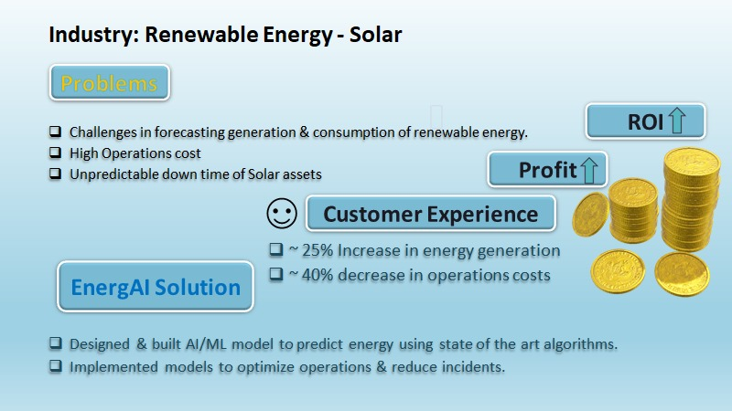

Figure 1: Specification of the company’s product initial discussed

**1.6 Summarized outcome of the literature review**

The review study carried out contained a proper study flow of the solar PV system and various steps followed in it. The research papers considered for research study was all published in the resent year after 2020 and the work proposed in each of the paper was to encourage the use of renewable energy. The review could be segregated into different segmentations. The first few papers of the review study were about the selection of an appropriate site, that is potential capability of the site for producing electricity and continuing to it the forth coming papers discussed about various monitoring system and data acquisition system. The later part of the review study gives important to the parameters that are having direct or indirect impact on the overall plant efficiency. Each study paper concentrated on individual parameter, their effect on the system performance and operation. Considering the research study one can concentrate on enhancing the operation and efficiency of the solar PV system. The later part of the review study includes the identification of the various faults happening in the solar PV system and the methodology involved in improving the plant performance & analysis of the solar PV system.

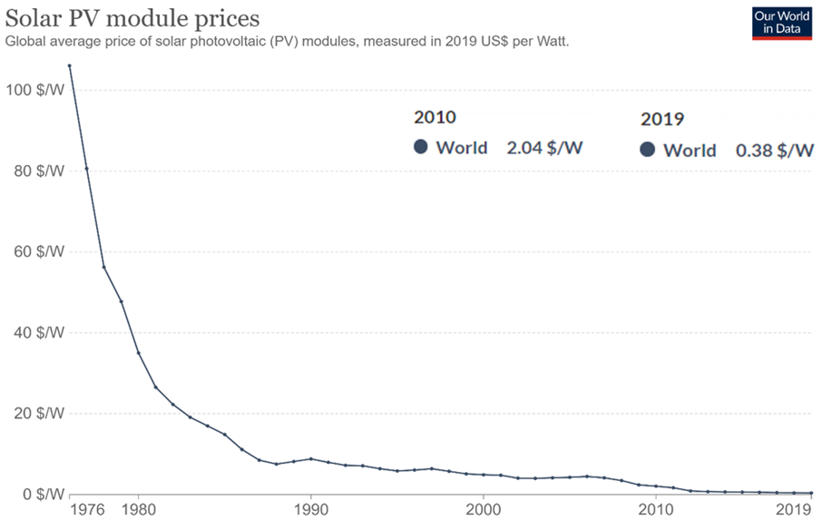

Figure 2: History of Solar PV Module Prices

**CHAPTER 2**

**BACKGROUND THEORY**

**2.1 Introduction**

This chapter is all about the pre discussions that was conducted before starting this project. A brief discussion about the background theory, how it started and what was the thoughts that made this project possible is discussed. The various formulas incorporated, and various concepts adopted into the project will be discussed in the chapter.

**2.2 Introduction to the project title**

The title of the project is very important for any project since the title should include or should outline what the project work is about. Discussion was made among the team members about the title of the project, later the title was given by our director of the company. Initially the project title given was EnergyAI which as name indicates the sector in which we are working on. Later the title was changed to EnergAI and finally it was confirmed as EnerGAI. Since the study proposed in the project includes Artificial intelligence, Green Energy it was finalized as EnerGAI. This project is building a product which belongs to solar pv, but the product is not fully developed so the title of the project was changed to “Development of visual AI dashboard for Solar pv systems” which include only the work done in internship period.

**2.3 Theoretical discussions and General circuit analysis**

Information related to the solar PV system like the details of different components that are used in the solar PV system, operation & maintenance procedures, all the basic knowledge that a person should know before starting the project was collected and was presented the same to the AI team to understand about solar pv system. Discussion happened between the AI & Domain team regarding the recent achievements and innovation in the field of solar PV system. Theoretical formulas used in the solar PV system to identify different parameters like Tilt Angle, Orientation, inter row module distance, inverter sizing etc., and their background theory was documented and presented to the company. Since there is huge development in the solar PV sector a discussion and identification on the short comes that are present in the solar PV system was carried out. Which led us to identify the project objective and started to work on it, eventually came up a methodology flow chart which included the process followed to achieve the objective.

The methodology incorporated to study the solar PV system is unique and helpful in achieve the objective of the project. The total solar PV system is divided into four different blocks to make it easier to understand and identify the concepts/flaws of the PV system. The first Block includes the solar PV modules, combiner box and rest all equipment that is installed which comes in the process of generating the DC power. The second Block consists of inverter a very important equipment of the PV system which converts the DC power generated into useful AC power. The Block 3 consists of ACDB which is distribution of the AC power coming from the output terminal of the inverter. It also includes the multi-function meter which help reading different parameters values. The fourth block includes the SCADA system, or the Monitoring system and various sensors required like wind speed sensor, module temperature sensor, irradiance sensor, wind direction sensor, ambient sensor etc. for a pv system. Data acquisitions system also comes under this blook which contribute to understanding the operations of the PV system.

The different equipment’s used in the system and the segregation of it into different Blocks can be identified in figure 3 and every block gives us a specific type of data which is interrelated with other Block and establishes the correlation between them. The process involved in generating DC power and power entering the inverter it is called DC section and the process of converting the DC power into useful AC power with the help of inverter is called the AC section. In most of the cases for the underperformance of the solar PV system is from the Block 1, due to the poor maintenance or due to the poor installation quality. By having some knowledge about data analytical it makes easier to identify the root cause of underperformance during the daily plant operation. Different losses happening in the different blocks are listed by going through variety of articles, research papers and videos published by industry experts. My work in this project includes go through all the websites related to solar PV system, follow the recent article related to the PV system, looking into varies videos recorded by the industry people or by experts in the industry, and keeping a record of it in a well-mannered documentation and presenting it to the company director.

**2.4 Conclusions**

In this chapter a brief theory about the initial discussion that was conducted for the project and about the outcomes of that discussion. It also includes the initial steps taken to build the project. Since this project involves a large process of building a wed application which has different tab section and different visual dashboards that contains large number of parameters in it. Theoretical formals that were used were converted to code which is incorporated in machine learning models which automatically calculate the accurate values of different parameters that helps in improving the overall efficiency of the solar PV system. Depending on the formulas that used there were different machine learning models and python libraries utilized in this project.

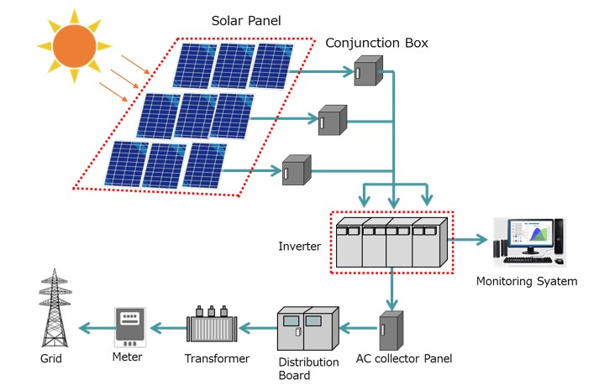

Figure 3: Working and Various equipment’s of Solar PV system [42]

**CHAPTER 3**

**METHODOLOGY**

**3.1 Introduction**

This chapter includes the discussion about the methodology that is considered to the project work which is proposed to the company. This chapter holds many blocks diagram and flowchart of the methodology followed in the project. Varies step involved in the methodology is explained and the different steps worked/carried out is listed, Various tools used, and formulas utilized in the project work is included in this chapter.

**3.2 Proposed Methodology**

The methodology used in this project helps in identifying the performance and efficiency of the PV system, where the first step would be to collect all the data that is available on the considered solar PV system. Once all the data has been collected it will be sent across different teams to analysis and is categorized into various parts by different teams. my area was related to domain work in pv system, the technical data that is available on considered solar PV system, right from the size of the plant, specification & data sheet of various equipment’s installed were collected and documented. with the help of Theoretical formulas, the solar PV design analysis will be caried out by identifying if there are any depletion in the system installed by checking the basic criteria required by the plant like tilt angle, orientation, inter-row distance, string sizing, average annual solar irradiance of the site, ambient temperature, cell temperature, place of inverter installed, and site inspection. Check for all the required equipment’s like protection devises, earthing components and sensors for data collection are working properly or installed/not. After analysing all the additional data that must be collected for further calculation will be listed.

Next, performance analysis will be conducted for each equipment’s installed and faulty equipment is corrected or replaced by a better one. For the collected data we design a complete statical analysis of the PV system so that it would be easier to analyse the PV system in the vast number of data that is being logged in and will be analysed in real-time. Once the performance Analysis is completed on the PV system, we get to know the current condition of the PV system.

The next step is creating a visual dashboard. The visual dashboard consists of different Pages, each one having their own advantages. The ‘overview’ page shows the regular monitoring parameters like total generation (AC/DC), hourly generation, total consumption, hourly consumption, meteorology data and addition to those other parameters like equivalent to number of trees planted, carbon dioxide saved, equivalent number of oil barrels and location of the pv system can be seen in the dashboard. The other pages include Key performance indicator, device performance, savings, and reports. The visual dashboard can be categorized into three different solutions like organizing, managing, and improving.

Future prediction of different parameters is calculated to enhance the performance and are implemented in the real time operation and accuracy are noted. There are various KPI parameters shown in the visual dashboard which help the costumer in understanding the real time performance of the plant. Certain threshold values will be set for different parameters and with the help of that we can categories the parameters that are not up to the mark which are the reason for the under performance of the power plant. As well as we also give importance to the other parameters that are up to the mark and give some inputs to increasing value of those parameters so that the performance increases and runs uninterruptedly. The parameters that are not up to the mark are considered and work on it to analysis the error and help in improving it by considering the standard way of PV system operation and maintenance.

Few additional methods can be caried out to increase the performance and efficiency of the pv system in all the possible ways by applying the best way of practice that is being carried out in solar PV Industry. Depending on the type of PV system different solution can be applied to increase the overall power generation of the PV system. The overview of the plant is checked once again in the end and the parameters which must be monitored regularly are added in the dashboard of the pv system which helps in preventing the errors and to maintain the flow of generation.

**3.3 Data Preprocessing Steps considered for developing Machine Learning models**

1. Obtaining the dataset: Obtaining the dataset will be the first process in dataset pre-processing for machine learning. To develop & build ML models, all we need is to get the appropriate dataset. The same dataset will be encompassed of data collected through several dissimilar sources that will be later combined into an appropriate format for developing a dataset. Dataset organizations vary corresponding to use cases depending on the objective of the project weather to analyze, identify, rectify and many other processes.

2. All the necessary libraries should be imported: The main three Python libraries implemented in data pre-processing of machine learning are “NumPy” which is better in scientific calculation and would be the fundamental package for data preprocessing in Python. Hence, any type of mathematical operation in the code can be inserted and large multidimensional arrays and matrices can be added in the code. The other important library is “Pandas”, for data analysis and manipulation it is an excellent open-source Python library. For managing and importing the datasets pandas is used extensively and it is a high performance easy to use data structure & data analysis tools for python. Another important library is “Mat2plotlib”which is a 2D plotting library used in plotting different kind of charts in python. It can deliver publication-quality figures in numerous hard copy formats and interactive environments across platforms like Jupiter notebook, I Python shells, web application servers, etc.

3. Importing the dataset: In this step, the datasets are imported that would be assembled for the machine learning project. In the whole process of data pre-processing in machine learning importing part of the dataset is very important.

4. Managing and Identifying the missing values: In data pre-processing, it is pivotal to recognize and accurately handle the absent values, or it might lead to inaccurate & faulty conclusion if absent values and inferences from the data are not recognized or handled.

5. Encoding the categorical data: The information that has specific categories within the dataset is referred to Categorical data.

6. Splitting the dataset: The next step in data pre-processing is Splitting the dataset. Every dataset for Machine Learning model must be split into two separate sets, Training dataset & Test dataset. The two datasets are training dataset and validation (test) dataset, in the CNN architecture used for image processing training dataset used was 640 images which will be used for training the model and other one is validation dataset which we used 160 images which is only used to evaluate the model's performance.

The data received by the company was having fewer data parameters, hence AI team combined few more parameters that was collected from opensource dataset sources to start with the data analysis part of the project. We assumed the location of the plant, size of the plant, plant capacity and few more parameters from the given data since the information were not mentioned with the data. To perform some calculation like to find the interrow distance we need the size of the panel, and we just took standard panel size. To calculate the azimuthal and tilt angle we were provided with the coordinates of the plant location. The location that was assigned was Raj gad with Coordinate Latitude is Raj gad- $21.17°$. The various data preprocessing steps explained in previous research work is shown as a block diagram in figure 5.

**3.4 List of steps conducted in the project to achieve the objective**

* Basic understanding of the Business problem.
* The Dataset was collected and performed the Data cleaning.
* EDA (Exploratory data analysis) and visualization were performed.
* Feature Engineering, to find out the anomalies and outliers in the dataset.
* Model building, using Machine Learning Algorithm.
* Generation and power loss prediction using linear regression and comparing it with random forest prediction.
* Forecasted weather data and its effect on Energy generation was discussed.
* Provided with the inverter dataset to find the faulty machine.
* Prediction/Calculation of Tilt angle and Maximum temperature w.r.t days using Arima model.
* Prediction of the Rain for upcoming days with the help of weather data using LSTM model.
* Comparison between the real energy consumption and predicted energy consumption.
* Carbon saving/Carbon footprint of the solar PV system was calculated.

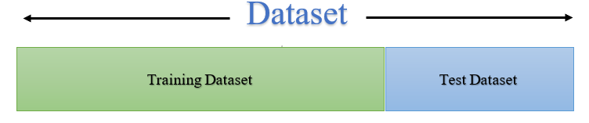

*Figure 4: Partitioning of given data*

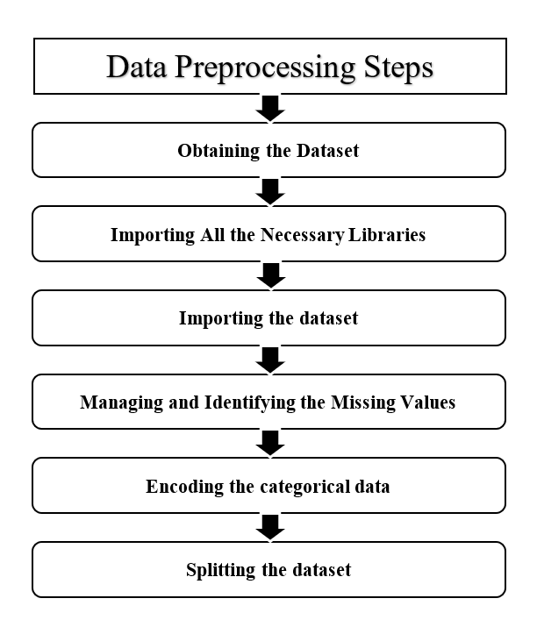

*Figure 5: Flowchart of Data Pre-processing steps*

The figure 6 represents the one-line diagram which indicates the proposed work by the team to the company for the initial data that was received, the purpose was to minimize the energy wastage. The diagram explains the required steps to be followed for future prediction of different parameters and identifying the power losses. The energy which is not used can be stored in a battery and can be used for later part of the day. In this diagram the initial step is to collect the generation data & consumption data and combine the given data with the API data (weather dataset). The next process is to clean the data and segregate the required data, look for any missing data. The next step is to calculate the difference between the energy generated & consumed, later the average of what the energy is being wasted is calculated and can identify the required energy for later part of the day by energy auditing. By knowing the required energy for the later part of the day an addition backup energy storage can be installed and a charge controller can be integrated to it for smooth functioning and extending the lifespan of the battery.

The secondary part of this diagram is to predict the future values using ARIMA, LSTM and Linear regression models. The next step is to identify if there are any errors and repeat the process again.

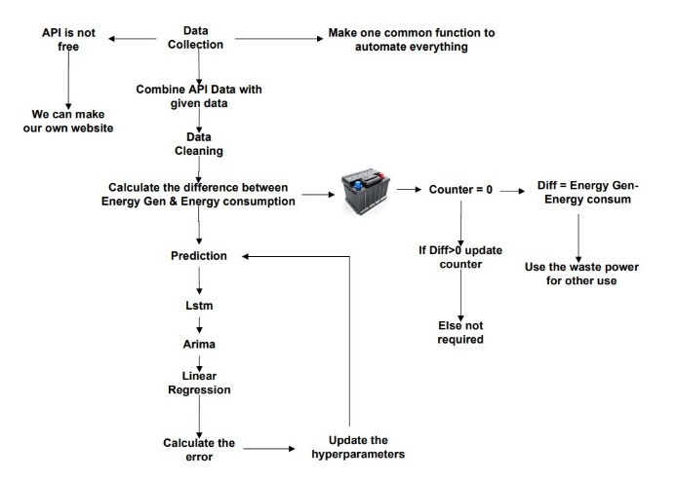

Figure 6: One-line diagram of the proposed work for the initial data received

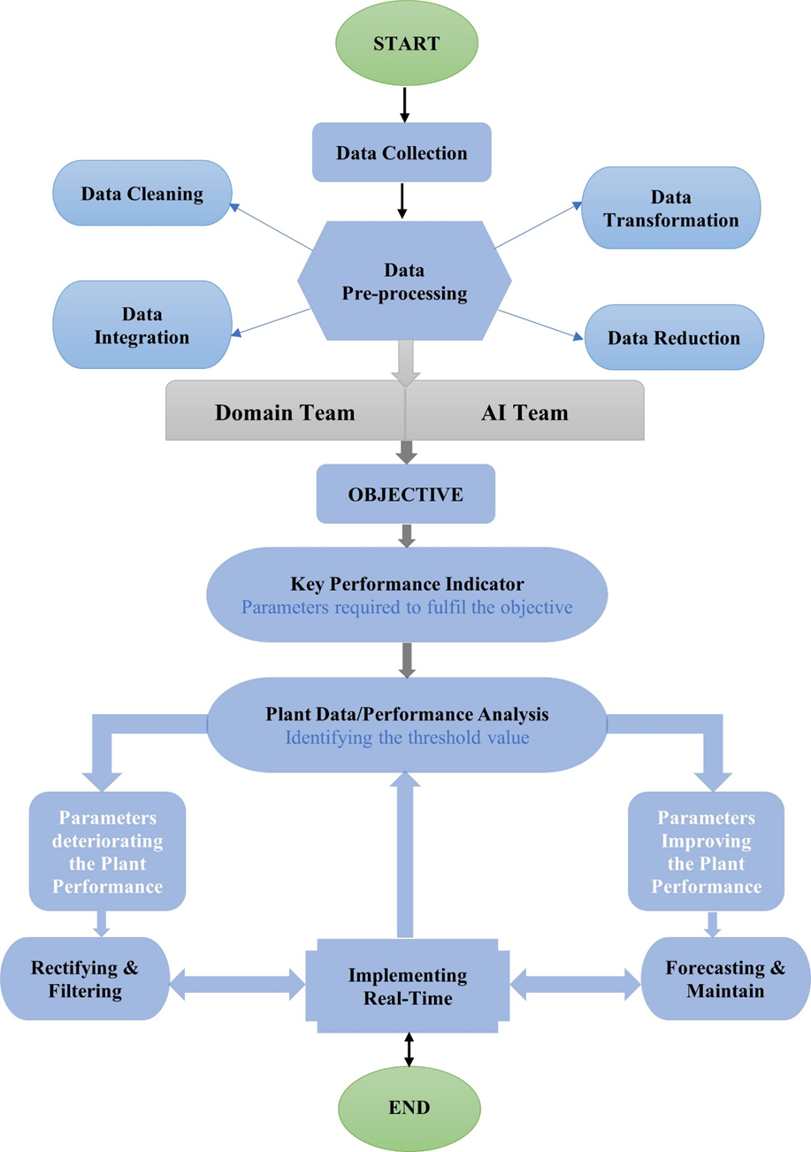

Figure 7: Flowchart of the methodology

**3.5 Key Performance Indicator-(KPI):**

KPIs are used at multiple stages of operation of a solar power plant to evaluate their success rating at reaching the specified targets which must be maintained and record of daily, monthly, and annually. To bring a transparency to maintenance & operations and to improve the process of operations there are few things to be noted/rectified in the initial stages of the plant installation. There are mainly four key factors to be considered and they are Objective of the project, Quantification of the objective, Implementation process and the Timeframe of it. The key factors that are considered under key performance indicator are:

* 1. To evaluate the performance of the pv system.
  2. To improve the efficiency of the solar photovoltaic system.
  3. To achieve maximum power output from the System.
  4. To improve energy and finance losses.
  5. To reduce carbon footprint.
  6. To make a smart system which can interact with each other to improve performance.
  7. To improve the revenue of the company.

Out of the above-mentionedkey factors only the evaluation of the pv system is considered in this project since it requires large amount of data. KPI is one among the many outcomes of the researched was not able to implement and validate in this project. But among the various key performance indicator mentioned below only few of the key performance indicators are included in the project work like inverter efficiency, peak sun hours, irradiance received. The below list represents the various parameters that are regularly monitored in solar pv system for preventive maintenance of the pv system.

1. PR - Performance ratio
2. DCC - DC Capacity
3. ACC - AC Capacity
4. Inverter Efficiency
5. Total System Efficiency
6. Specific Yield
7. Consumption By Sector
8. Power Factor
9. Uptime/downtime per inverter
10. Clipping ratio per inverter
11. Average current per string
12. PI - Peak Irradiance
13. PSH - Peak Solar Hours
14. PA - Plant availability
15. MTTR - Mean time to repair
16. MTBF - Mean time Between Failures
17. Module Soiling Losses
18. Capacity Factor
19. Degradation of Modules
20. Normalized efficiency
21. TT - Ticket Types %

**3.6 Tools used**

1. **Python**:Python is a very good tool which provides framework for AI and can fulfils all the need required in this field. It is one of the most popular programming languages used in AI and easy-to-use tool for visualization. Python Tensor-flow library developed by google brain. Python version used is greater than 3.7version.
2. **Flask** **and** **Django** **Framework**:This are the frameworks used in our project. The reason for selecting is because it was informed by the company.
3. **Microsoft Excel**: It is used for Data storage and cleaning. We use the stored data file for importing the data and exporting the data. Programs are built and correct analysis are identified with the help of excel and its vast functions. Excel is also used as a visualization tool where we can analyse vast number of data using different charts available.
4. **PVsyst**: Helps in modelling the PV system and identify different errors and analysis. PVsyst is a free access tool for beginners with limited features to learn more solar PV designing.
5. **Google colab**: it’s a free workspace where we can import a dataset of various images, image classifier can be trained with the help of it, and finally the models can be evaluated with few lines of coding.
6. **Jupyter-Notebook**: The Jupyter Notebook is free access web application that is used to create, share, and download documents that includes live code visualization, formulas in the form of equation and text from isolated place faraway places.
7. **VS code**: Visual Studio Code is a streamlined code editor with support for development operations like debugging, task running, and version control. It aims to provide just the tools a developer needs for a quick code-build-debug cycle and leaves more complex workflows to fuller featured IDEs, such as Visual Studio IDE.

**3.7 Formulas used for calculation:**

*1. Performance Ratio*

$$P.R=\frac{E_grid}{GII×{PV}_{DC}} …(1)$$

$E_grid$ Energy Generated $(kwh)$

$GII$ Global Inclined Irradiation $(kwh/m^{2})$

${PV}_{DC}$ PV module installed DC capacity $(kw)$

*2. Inverter Efficiency*

$$η \left(\%\right)=\frac{P_{ac }}{P_{dc}} …(2)$$

$P_{ac}$ AC Power Output of Inverter $(kw)$

$P_{dc}$ DC Power Input to the Inverter $(kw)$

*3. Specific Yield*

$$S Y=\frac{E_{_gen} }{I_{c_DC} } …(3)$$

$E_{_gen}$ Energy Generation $(kwh)$

$I_{c_DC}$ Inverter DC connected Capacity $(kw_{p})$

*4. Angle of Declination*

$$\left(δ\right)=23.45°×\sin\left[ \frac{360}{365}×\left(d-81\right)\right] …(4)$$

*5. Hour Angle*

$$\left(H\right)=15° \left[LST-12 \right] …(5)$$

*6. Altitude Angle*

$$\sin{(AL)}=\left[\cos{(L)}×\cos{(δ)}×\cos{(H)}\right]+\left[\sin\left(L\right)×\sin\left(δ\right)\right] …(6)$$

*7. Zenith Angle*

$$\left(Z\right)= 90°-AL …(7)$$

*8. Azimuthal Angle*

$$\cos{(AZ)}=\frac{[\sin{(AZ)}×\sin{(L)}-\sin{(δ)}]}{[\cos{(AL)}×\cos{(L)}]} …(8)$$

*9. Fixed Tilt Angle*

$$\left(β\right)=\left|L-δ\right| …(9)$$

*10. Tracking Tilt Angle*

$$\tan{(β)}=\tan{(Z)}×\left|\cos{(AZ)}\right| …(10)$$

*11. Inter Module Row Distance*

$$D=H× \frac{\cos{(AZ)}}{\tan{(AL)}} …(11)$$

H Height of the module form the ground [$H=L×\sin{β}$]

L Length of the module

*12. Availability: Uptime/downtime per inverter*

$Availability \%=\frac{Uptime - Downtime}{Uptime} …(12)$

$Uptime$ Total number of generating hours.

*Downtime* Number of hours the inverter stops (maintenance, site tripped/offline, blown fuse etc.)

*13. Peak Solar Hour*

$Peak sun hours = \frac{Total daily Global In-Plane Irradiance (kwh/m^{2}) }{1000W/m²} …(13)$

*1 peak sun hour =* 1000 W/m² of sunlight per hour

*14. Mean time to repair*

$MTTR=\frac{\sum_{i=1}^{n}{t_{t_{Ai}}}}{Number of failures} …(14)$

$$i defines sampling time$$

$$n defines total sampling number$$

$$t_{Ai} defines failure periyod$$

*15. Mean time Between Failures*

$MTBF=\frac{\sum_{i=1}^{n}{(t_{{PK}_{i}}-t_{{ASC}_{i}})}}{Number of failures} …(15)$ $i Sampling time$

$n total sampling number$

$t_{{PK}_{i}} beginning time of unplanned power cut$

$t_{{ASC}_{i}} next restart time after unplanned power cut, respectively$

*16. Capacity Factor*

$CF=\frac{Actual average annual production (kWh)}{(365 days) × (24 hours/day) Installed capacity (kwp)} …(16)$

**3.6.2 Machine learning models used in the project work:**

**Motivation:** Solar and wind are intermittent Can we accurately forecast how much energy will we consume tomorrow? Difficult to estimate from “a priori” models But, we have lots of data from which to build a model.

1. **Linear regression**: linear regression is a linear approach for modelling the relationship between a scalar response and one or more explanatory variables.

Our data contains only one independent variable (𝑋X) which represents the date and the dependent variable (𝑌Y) we are trying to predict is the Stock Price. To fit a line to the data points, which then represents an estimated relationship between 𝑋X and 𝑌Y, we can use a Simple Linear Regression.

The best fit line can be described with

$$Y=β0+β1XY=β0+β1X$$

𝑌Y is the predicted value of the dependent variable 𝛽0β0 is the y-intercept 𝛽1β1 is the slope 𝑋X is the value of the independent variable The goal is to find such coefficients 𝛽0β0 and 𝛽1β1 that the Sum of Squared Errors, which represents the difference between each point in the dataset with its corresponding predicted value outputted by the model, is minimal.

1. **ARIMA model**: It is a statistical model used for analyzing and forecasting time series data. The expansion of the name of the model is Autoregressive Integrated Moving Average.

Autoregressive Integrated Moving Average is referred to as ARIMA. It incorporates the concept of integration and is a generalization of the easier Autoregressive Moving Average.

AR: Autoregression. A model that uses the dependent relationship between an observation and some number of lagged observations.

I: Integrated. The use of differencing of raw observations (e.g., subtracting an observation from an observation at the previous time step) in order to make the time series stationary.

MA: Moving Average. A model that uses the dependency between an observation and a residual error from a moving average model applied to lagged observations.

The model specifically specifies each of these elements as a parameter. To quickly identify the particular ARIMA model being utilized, a common notation known as ARIMA (p, d, q) is used instead of the parameters' actual values.

The parameters of the ARIMA model are defined as follows:

p: The number of lag observations included in the model, also called the lag order.

d: The number of times that the raw observations are differenced, also called the degree of differencing.

q: The size of the moving average window, also called the order of moving average.

The data is prepared by a degree of differencing to make it stationary, i.e., to remove trend and seasonal structures that adversely affect the regression model, and a linear regression model is developed with the given number and type of variables.

A parameter can have a value of 0, which denotes that the model should not use that particular component. In this approach, the ARIMA model can be set up to serve the same purpose as an ARMA model or even a straightforward AR, I, or MA model.

The assumption that an ARIMA process underlies an ARIMA model for a time series is that the process that produced the observations is an ARIMA process. This may seem simple, but it serves to highlight the need to validate the model's assumptions in the model's residual errors of projections.

1. **LSTM model**: It is a long-short term memory network. It will remember past knowledge that the network is seen so far and to forget irrelevant data using activation function called gates.

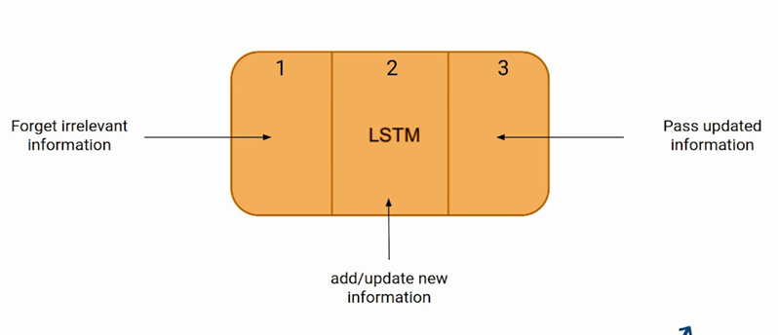A long short-term memory network, also known as an improved RNN or sequential network, enables information retention. It can fix the vanishing gradient problem of the RNN. Recurrent neural networks, often known as RNNs, are used for persistent memory.

Figure : Information Transfer [41]

The first part chooses whether the information coming from the previous timestamp is to be remembered or is irrelevant and can be forgotten. In the second part, the cell tries to learn new information from the input to this cell. At last, in the third part, the cell passes the updated information from the current timestamp to the next timestamp.

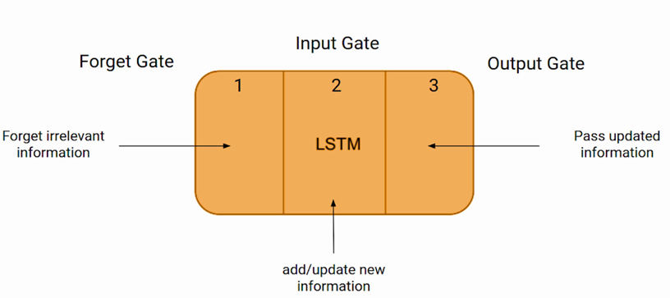These three parts of an LSTM cell are known as gates. The first part is called **Forget gate, the**second part is known as **the Input gate** and the last one is **the Output gate**.

Figure : Gates of LSTM [41]

Just like a simple RNN, an LSTM also has a hidden state where H(t-1) represents the hidden state of the previous timestamp and Ht is the hidden state of the current timestamp. In addition to that LSTM also have a cell state represented by C(t-1) and C(t) for previous and current timestamp respectively.

Here the hidden state is known as Short term memory and the cell state is known as Long term memory. Refer to the following image.

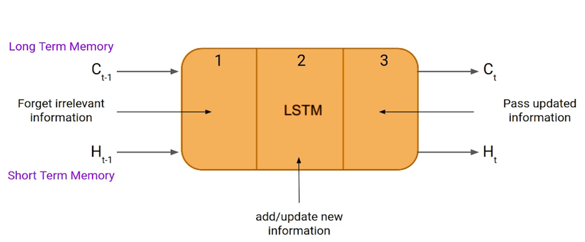LSTM functions on a high level very similarly to an RNN cell. The LSTM network's internal operation is seen below. As seen in the image below, the LSTM is composed of three sections, each of which has a distinct function.

Figure : Hidden State and cell state [41]

1. **Random forest**: Random Forest is a flexible, easy to use machine learning algorithm that produces great results most of the time with minimum time spent on hyper-parameter tuning.

The supervised learning method includes the well-known machine learning algorithm Random Forest. It can be applied to ML Classification and Regression issues. Its foundation is the idea of ensemble learning, which is the process of mixing various classifiers to solve a challenging problem and enhance the performance of the model.

Random Forest is a classifier that, as the name implies, "contains a number of decision trees on various subsets of the provided dataset and takes the average to enhance the predictive accuracy of that dataset." Instead of depending on a single decision tree, the random forest uses forecasts from all of the trees to anticipate the outcome based on which predictions received the most votes.

Why use Random Forest?

Below are some points that explain why we should use the Random Forest algorithm:

It takes less training time as compared to other algorithms.

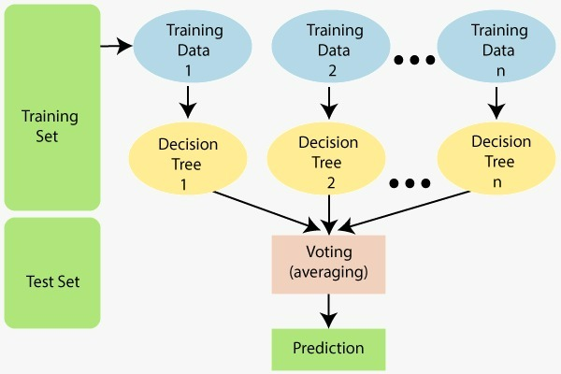It predicts output with high accuracy, even for the large dataset it runs efficiently.

Figure : Working of Random Forest Algorithm [42]

It can also maintain accuracy when a large proportion of data is missing.

Diagram explains the working of the Random Forest algorithm. The greater number of trees in the forest leads to higher accuracy and prevents the problem of overfitting.

Assumptions for Random Forest: Some decision trees might predict the right output, while others might not, because the random forest uses numerous trees to forecast the class of the dataset. But when all the trees are combined, they anticipate the right result. Consequently, the following two presumptions for an improved Random Forest classifier.

* There should be some actual values in the feature variable of the dataset so that the classifier can predict accurate results rather than a guessed result.
* The predictions from each tree must have very low correlations.

**3.6.1 Models used in the Image processing:**

Machine learning models is proposed to identify the visual condition of the solar modules using image processing techniques. The models are built to identify weather the solar modules are cleaned good panel, soiled panel, glass cracked panels, shadow of any obstacles nearby or any other obstacle fallen on the solar panel. Here we are trying to prevent the loss that could happen, or that might lead to underperformance of the power plant and the whole plant failure. To do this process we used CNN architectures like Inception v3, Resnet 50 & VGG 16, VGG19 and Efficient B0.

**Convolutional neural network (CNN):**

CNNs are a subclass of Deep Neural Networks that are frequently used for visual image analysis. CNNs can identify and categorise specific features from images. Their uses include natural language processing, image classification, video and image analysis for medical purposes, and image and video recognition.

Convolution is a mathematical process that involves multiplying two functions to create a third function that expresses how the form of one function is altered by the other. The term "convolution" is used in CNN to refer to this mathematical activity. To extract features from a picture, two images that can be represented as matrices are multiplied to produce an output.

Basic Architecture: There are two main parts to a CNN architecture

A convolution tool that separates and identifies the various features of the image for analysis in a process called as Feature Extraction. A fully connected layer that utilizes the output from the convolution process and predicts the class of the image based on 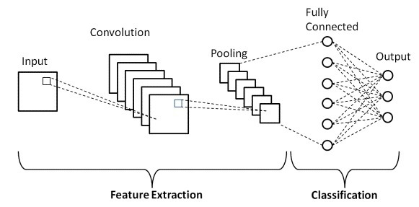the features extracted in previous stages.

Figure : Basic CNN Architecture [43]

Convolution Layers:

There are three types of layers that make up the CNN which are the convolutional layers, pooling layers, and fully connected (FC) layers. When these layers are stacked, a CNN architecture will be formed. In addition to these three layers, there are two more important parameters which are the dropout layer and the activation function which are defined below.

**1. Convolutional Layer**

This layer is the first layer that is used to extract the various features from the input images. In this layer, the mathematical operation of convolution is performed between the input image and a filter of a particular size MxM. By sliding the filter over the input image, the dot product is taken between the filter and the parts of the input image with respect to the size of the filter (MxM).

The output is termed as the Feature map which gives us information about the image such as the corners and edges. Later, this feature map is fed to other layers to learn several other features of the input image.

**2. Pooling Layer**

In most cases, a Convolutional Layer is followed by a Pooling Layer. The primary aim of this layer is to decrease the size of the convolved feature map to reduce the computational costs. This is performed by decreasing the connections between layers and independently operates on each feature map. Depending upon method used, there are several types of Pooling operations.

In Max Pooling, the largest element is taken from feature map. Average Pooling calculates the average of the elements in a predefined sized Image section. The total sum of the elements in the predefined section is computed in Sum Pooling. The Pooling Layer usually serves as a bridge between the Convolutional Layer and the FC Layer.

**3. Fully Connected Layer**

The Fully Connected (FC) layer consists of the weights and biases along with the neurons and is used to connect the neurons between two different layers. These layers are usually placed before the output layer and form the last few layers of a CNN Architecture.

In this, the input image from the previous layers are flattened and fed to the FC layer. The flattened vector then undergoes few more FC layers where the mathematical functions operations usually take place. In this stage, the classification process begins to take place.

**4. Dropout**

Usually, when all the features are connected to the FC layer, it can cause overfitting in the training dataset. Overfitting occurs when a particular model works so well on the training data causing a negative impact in the model’s performance when used on a new data.

To overcome this problem, a dropout layer is utilised wherein a few neurons are dropped from the neural network during training process resulting in reduced size of the model. On passing a dropout of 0.3, 30% of the nodes are dropped out randomly from the neural network.

**5. Activation Functions**

Finally, one of the most important parameters of the CNN model is the activation function. They are used to learn and approximate any kind of continuous and complex relationship between variables of the network. In simple words, it decides which information of the model should fire in the forward direction and which ones should not at the end of the network.

It adds non-linearity to the network. There are several commonly used activation functions such as the ReLU, Softmax, tanH and the Sigmoid functions. Each of these functions have a specific usage. For a binary classification CNN model, sigmoid and softmax functions are preferred a for a multi-class classification, generally softmax us used.

1. **Resnet 50:** All the previous models used deep neural networks in which they stacked many convolution layers one after the other. It was learnt that deeper networks are performing better [41]. However, it turned out that this is not true. 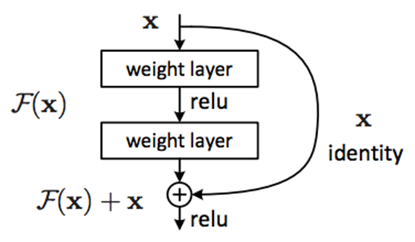Following are the problems with deeper networks:

* Network becomes difficult to optimize
* Vanishing / Exploding Gradients

Figure : Skip connection [45]

* Degradation Problem (accuracy first saturates and then degrades)

Skip Connections:

So, to address these problems, authors of the resnet architecture came up with the idea of skip connections with the hypothesis that the deeper layers should be able to learn something as equal as shallower layers. A possible solution is copying the activations from shallower layers and setting additional layers to identity mapping. These connections are enabled by skip connections which are shown in the following figure.

So, the role of these connections is to perform identity function over the activation of shallower layer, which in-turn produces the same activation. This output is then added with the activation of the next layer. To enable these connections or essentially enable this addition operation, one need to ensure the same dimensions of convolutions throughout the network, that's why resnets have same 3 by 3 convolutions throughout.

**Table 1:** Now we are going to discuss about Resnet 50 and also the architecture for the above talked 18- and 34-layer ResNet is also given residual mapping and not shown for simplicity.

There was a small change that was made for the ResNet 50 and above that before this the shortcut connections skipped two layers but now, they skip three layers and also there was $1×1$ convolution layers added that we are going to see in detail with the ResNet 50 Architecture.

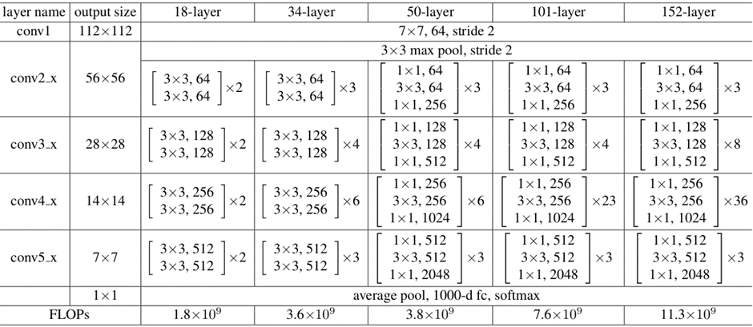So, as we can see in the table 1 the resnet 50 architecture contains the following elements.

Figure : ResNet’s Architecture [45]

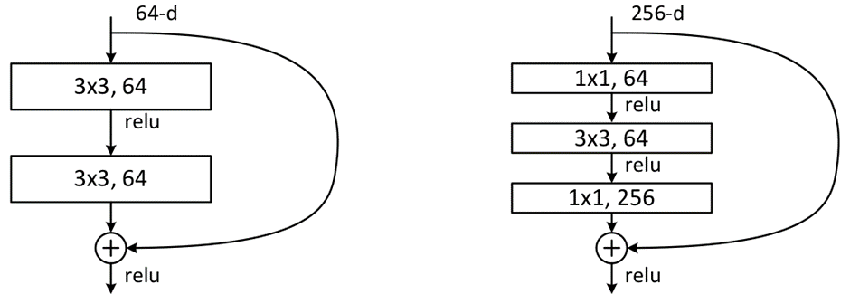A convolution with a kernel size of $7×7$ and 64 different kernels all with a stride of size 2 giving us 1 layer.

Figure : Skip connection 3 layers [45]

Next, we see max pooling with also a stride size of 2.

In the next convolution there is a $1×1$,64 kernel following this a 3 $×3$,64 kernel and at last a $1×1$,256 kernel, these three layers are repeated in total 3 time so giving us 9 layers in this step.

Next, we see kernel of $1×1$,128 after that a kernel of $3×3$,128 and at last a kernel of $1×1$,512 this step was repeated 4 time so giving us 12 layers in this step.

After that there is a kernel of $1×1$,256 and two more kernels with 3 $×3$,256 and $1×1$,1024 and this is repeated 6 time giving us a total of 18 layers.

And then again a $1×1$,512 kernel with two more of $3×3$,512 and $1×1$,2048 and this was repeated 3 times giving us a total of 9 layers.

After that we do a average pool and end it with a fully connected layer containing 1000 nodes and at the end a SoftMax function so this gives us 1 layer.

We don't actually count the activation functions and the max/ average pooling layers.

so, totaling this it gives us a 1 + 9 + 12 + 18 + 9 + 1 = 50 layers Deep Convolutional network.

1. **VGG 16:**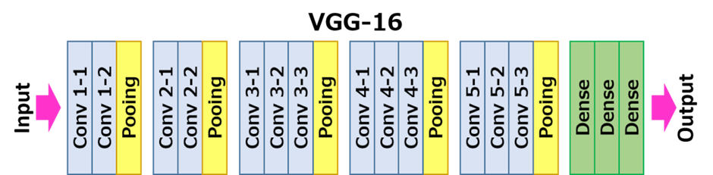VGG16 is a convolutional neural network model proposed by K. Simonyan and A. Zisserman from the University of Oxford in the paper “Very Deep Convolutional Networks for Large-Scale Image Recognition”. The model achieves 92.7% top-5 test accuracy in ImageNet, which is a dataset of over 14 million images belonging to 1000 classes. It was one of the famous model submitted to ILSVRC-2014. It makes the improvement over AlexNet by replacing large kernel-sized filters (11 and 5 in the first and second convolutional layer, respectively) with multiple 3×3 kernel-sized filters one after another. VGG16 was trained for weeks and was using NVIDIA Titan Black GPU’s.

Figure : Architecture of VGG-16

1. **VGG16 Architecture:**

The input to cov1 layer is of fixed size 224 x 224 RGB image. The image is passed through a stack of convolutional (conv.) layers, where the filters were used with a very small receptive field: 3×3 (which is the smallest size to capture the notion of left/right, up/down, center). In one of the configurations, it also utilizes 1×1 convolution filters, which can be seen as a linear transformation of the input channels (followed by non-linearity). The convolution stride is fixed to 1 pixel; the spatial padding of conv. layer input is such that the spatial resolution is preserved after convolution, i.e., the padding is 1-pixel for 3×3 conv. layers. Spatial pooling is carried out by five max-pooling layers, which follow some of the conv.  layers (not all the conv. layers are followed by max-pooling). Max-pooling is performed over a 2×2-pixel window, with stride 2.

Three Fully Connected (FC) layers follow a stack of convolutional layers (which has a different depth in different architectures): the first two have 4096 channels each, the third performs 1000-way ILSVRC classification and thus contains 1000 channels (one for each class). The final layer is the soft-max layer. The configuration of the fully connected layers is the same in all networks.

All hidden layers are equipped with the rectification (ReLU) non-linearity. It is also noted that none of the networks (except for one) contain Local Response Normalisation (LRN), such normalization does not improve the performance on the ILSVRC dataset but leads to increased memory consumption and computation time.

Configurations:

The ConvNet configurations are outlined in figure 2. The nets are referred to their names (A-E). All configurations follow the generic design present in architecture and differ only in the depth: from 11 weight layers in the network A (8 conv. and 3 FC layers) to 19 weight layers in the network E (16 conv. and 3 FC layers). The width of conv. layers (the number of channels) is rather small, starting from 64 in the first layer and then increasing by a factor of 2 after each max-pooling layer, until it reaches 512.

Use-Cases and Implementation

Unfortunately, there are two major drawbacks with VGGNet:

1. It is painfully slow to train.
2. The network architecture weights themselves are quite large (concerning disk/bandwidth).

Due to its depth and number of fully connected nodes, VGG16 is over 533MB. This makes deploying VGG a tiresome task. VGG16 is used in many deep learning image classification problems; however, smaller network architectures are often more desirable (such as SqueezeNet, GoogLeNet, etc.). But it is a great building block for learning purpose as it is easy to implement.

1. **VGG19:** VGG19 is a variant of VGG model which in short consists of 19 layers (16 convolution layers, 3 Fully connected layer, 5 MaxPool layers and 1 SoftMax layer). There are other variants of VGG like VGG11, VGG16 and others. VGG19 has 19.6 billion FLOPs.

Background: AlexNet came out in 2012 and it improved on the traditional Convolutional neural networks, so we can understand VGG as a successor of the AlexNet but it was created by a different group named as Visual Geometry Group at Oxford's and hence the name VGG, It carries and uses some ideas from its predecessors and improves 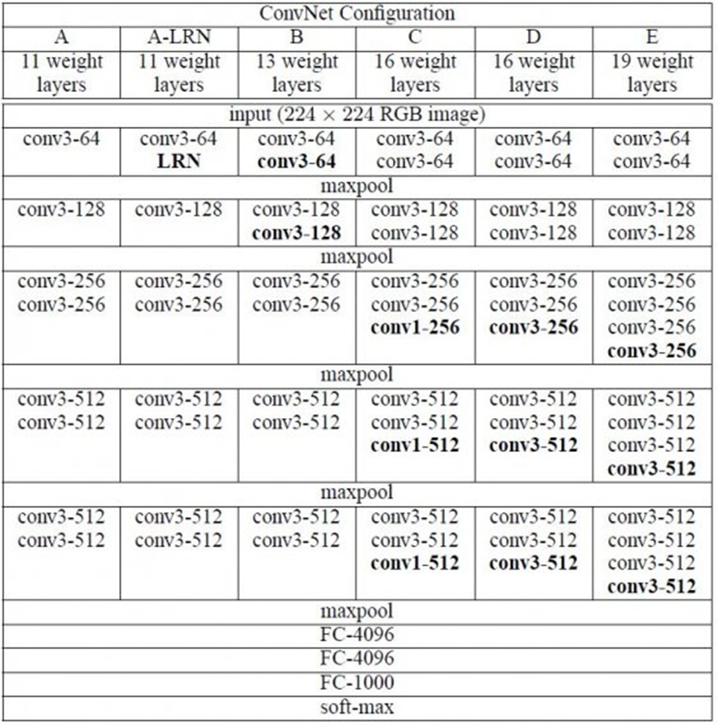on them and uses deep Convolutional neural layers to improve accuracy.

Figure : ConvNet Configuration

Let's explore what VGG19 is and compare it with some of other versions of the VGG architecture and also see some useful and practical applications of the VGG architecture.

Before diving in and looking at what VGG19 Architecture is let's take a look at ImageNet and a basic knowledge of CNN.

* [Convolutional Neural Network (CNN)](https://iq.opengenus.org/convolutional-neural-networks/)

First of all, let’s explore what [ImageNet](http://www.image-net.org/) is. It is an Image database consisting of 14,197,122 images organized according to the WordNet hierarchy. this is a initiative to help researchers, students and others in the field of image and vision research.

ImageNet also hosts contests from which one was ImageNet Large-Scale Visual Recognition Challenge (*ILSVRC*) which challenged researchers around the world to come up with solutions that yields the lowest top-1 and top-5 error rates (top-5 error rate would be the percent of images where the correct label is not one of the model’s five most likely labels). The competition gives out a 1,000-class training set of 1.2 million images, a validation set of 50 thousand images and a test set of 150 thousand images and here comes the VGG Architecture, in 2014 it out-shined other state of the art models and is still preferred for a lot of challenging problems.

VGG is a deep CNN used to classify images. The layers in VGG19 model are as follows

**Architecture:**

* A fixed size of (224 * 224) RGB image was given as input to this network which means that the matrix was of shape (224,224,3).
* The only preprocessing that was done is that they subtracted the mean RGB value from each pixel, computed over the whole training set.
* Used kernels of (3 * 3) size with a stride size of 1 pixel, this enabled them to cover the whole notion of the image.
* spatial padding was used to preserve the spatial resolution of the image.
* max pooling was performed over a 2 * 2-pixel windows with sride 2.
* this was followed by Rectified linear unit (ReLu) to introduce non-linearity to make the model classify better and to improve computational time as the previous models used tanh or sigmoid functions this proved much better than those.
* implemented three fully connected layers from which first two were of size 4096 and after that a layer with 1000 channels for 1000-way *ILSVRC* classification and the final layer is a softmax function.

Uses of the VGG Neural Network: The main purpose for which the VGG net was designed was to win the ILSVRC*,* but it has been used in many other ways.

* Used just as a good classification architecture for many other datasets and as the authors made the models available to the public they can be used as is or with modification for other similar tasks also.
* Transfer learning: can be used for facial recognition tasks also.
* weights are easily available with other frameworks like keras so they can be tinkered with and used for as one wants.

1. **Inception v3:** Inception V3 Model Architecture, the inception v3 model was released in the year 2015, it has a total of 42 layers and a lower error rate than its predecessors. Let's look at what are the different optimizations that make the inception V3 model better.

The major modifications done on the Inception V3 model are,

1. Factorization into Smaller Convolutions
2. Spatial Factorization into Asymmetric Convolutions
3. Utility of Auxiliary Classifiers
4. Efficient Grid Size Reduction

Let's how each one of these optimizations was implemented and how it improved the model.

Factorization into Smaller Convolutions

One of the major assets of the Inception V1 model was the generous dimension reduction. To make it even better, the larger Convolutions in the model were factorized into smaller Convolutions.

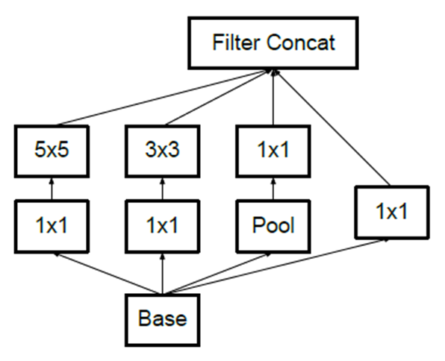For example, consider the basic module of the inception V1 module.It has a 5×5 convolutional layer which was computationally expensive as said before. So, to reduce the computational cost the 5×5 convolutional layer was replaced by two 3×3 convolutional layers as shown below.

Figure : Basic Inception module

To understand it better see how the process of using two 3×3 convolutions reduce the number of parameters.

As a result of the reduced number of parameters the computational costs also reduce. This factorization of larger convolutions into smaller convolutions resulted in a relative gain of 28%.

Spatial Factorization into Asymmetric Convolutions

Even though the larger convolutions are factorized into smaller convolutions. You may wonder what if we can factorize furthermore for example to a 2×2 convolution. But a better alternative to make the model more efficient was Asymmetric convolutions.

Asymmetric convolutions are of the form n×1.

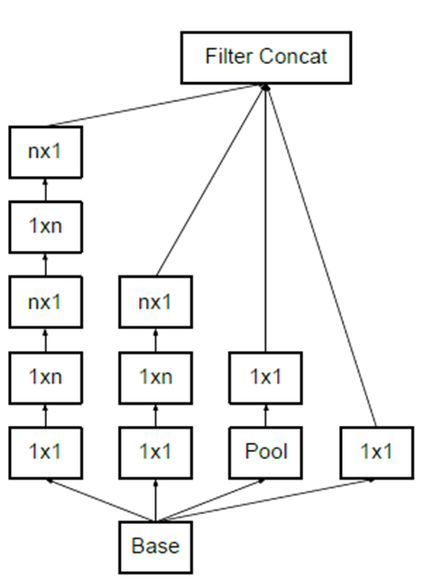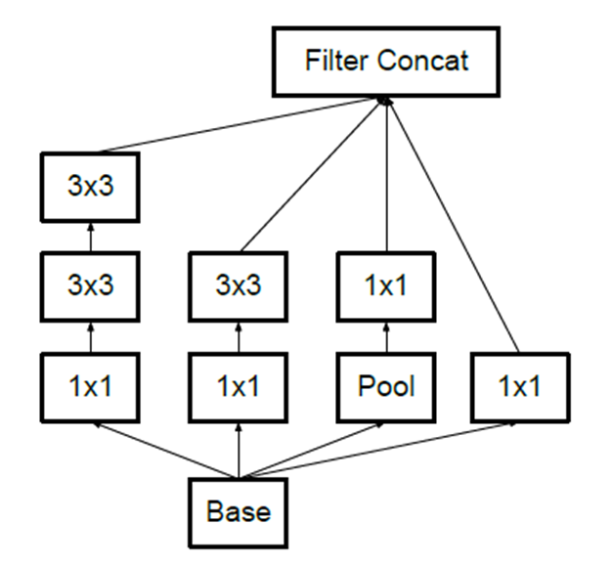So, what they did is replace the 3×3 convolutions with a 1×3 convolution followed by a 3×1 convolution. Doing so is the same as sliding a two-layer network with the same receptive field as in a 3×3 convolution.

Figure : Structure of Asymmetric Convolutions

Figure : Two 3×3 convolutional layers

The two-layer solution is 33% cheaper for the same number of output filters if the number of input and output filters is equal.

Utility of Auxiliary classifier:

After applying the first two optimization techniques the inception module looks like this.

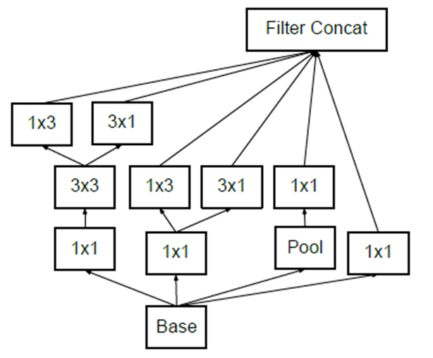The objective of using an auxiliary classifier is to improve the convergence of very deep neural networks. The auxiliary classifier is mainly used to combat the vanishing gradient problem in very deep networks.

Figure : Utility of Auxiliary classifiers

The auxiliary classifiers didn't result in any improvement in the early stages of the training. But towards the end, the network with auxiliary classifiers showed higher accuracy compared to the network without auxiliary classifiers.

Thus the auxiliary classifiers act as a regularizer in Inception V3 model architecture.

**Efficient Grid Size Reduction:**

Traditionally max pooling and average pooling were used to reduce the grid size of the feature maps. In the inception V3 model, in order to reduce the grid size efficiently the activation dimension of the network filters is expanded.

For example, if we have a d×d grid with k filters after reduction it results in a d/2 × d/2 grid with 2k filters and this is done using two parallel blocks of convolution and pooling later concatenated.

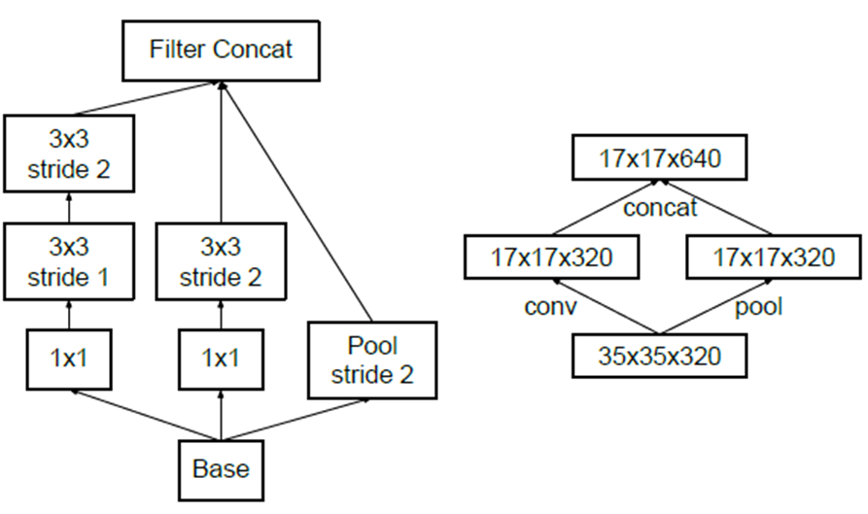The above image shows how the grid size is reduced efficiently while expanding the filter banks.

Figure : Two parallel blocks of convolution and pooling

The final Inception V3 model:

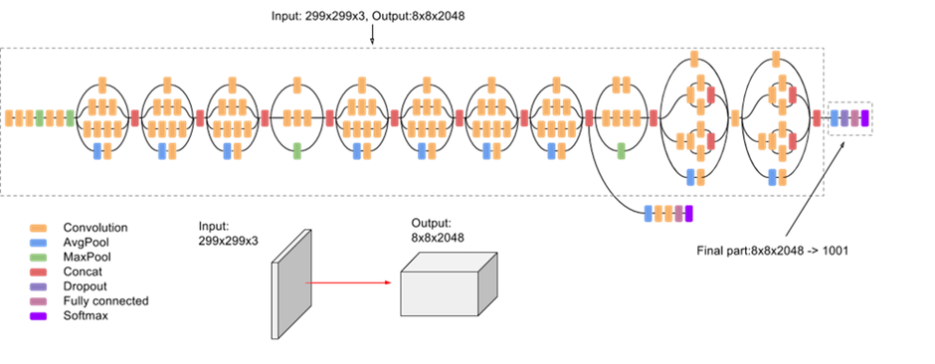After performing all the optimizations, the final Inception V3 model looks like this

Figure : final Inception V3 model [46]

In total, the inception V3 model is made up of 42 layers which is a bit higher than the previous inception V1 and V2 models. But the efficiency of this model is really impressive. We will get to it in a bit, but before it let's just see in detail what are the components the Inception V3 model is made of.

Table 1: Outline of the Inception v3 module

| **TYPE** | **PATCH / STRIDE SIZE** | **INPUT SIZE** |
| --- | --- | --- |
| Conv | 3×3/2 | 299×299×3 |
| Conv | 3×3/1 | 149×149×32 |
| Conv padded | 3×3/1 | 147×147×32 |
| Pool | 3×3/2 | 147×147×64 |
| Conv | 3×3/1 | 73×73×64 |
| Conv | 3×3/2 | 71×71×80 |
| Conv | 3×3/1 | 35×35×192 |
| 3 × Inception | Module 1 | 35×35×288 |
| 5 × Inception | Module 2 | 17×17×768 |
| 2 × Inception | Module 3 | 8×8×1280 |
| Pool | 8 × 8 | 8 × 8 × 2048 |
| Linear | Logits | 1 × 1 × 2048 |
| Softmax | Classifier | 1 × 1 × 1000 |

The above table describes the outline of the inception V3 model. Here, the output size of each module is the input size of the next module. The above table describes the outline of the inception V3 model. Here, the output size of each module is the input size of the next module.

Performance of Inception V3:

As expected, the inception V3 had better accuracy and less computational cost compared to the previous Inception version.

We can see that the inception V3 model has an extremely low error rate compared with its previous models and its contemporaries.

1. **EfficientNet-b0:**

EfficientNet Architecture: The effectiveness of model scaling also relies heavily on the baseline network. So, to further improve performance, we have also developed a new baseline network by performing a neural architecture search using the AutoML MNAS framework, which optimizes both accuracy and efficiency (FLOPS). The resulting architecture uses mobile inverted bottleneck convolution (MBConv), similar to 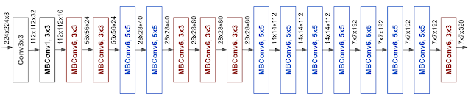MobileNetV2 and MnasNet, but is slightly larger due to an increased FLOP budget. We then scale up the baseline network to obtain a family of models, called EfficientNets.

Figure : Architect of Efficient-B0

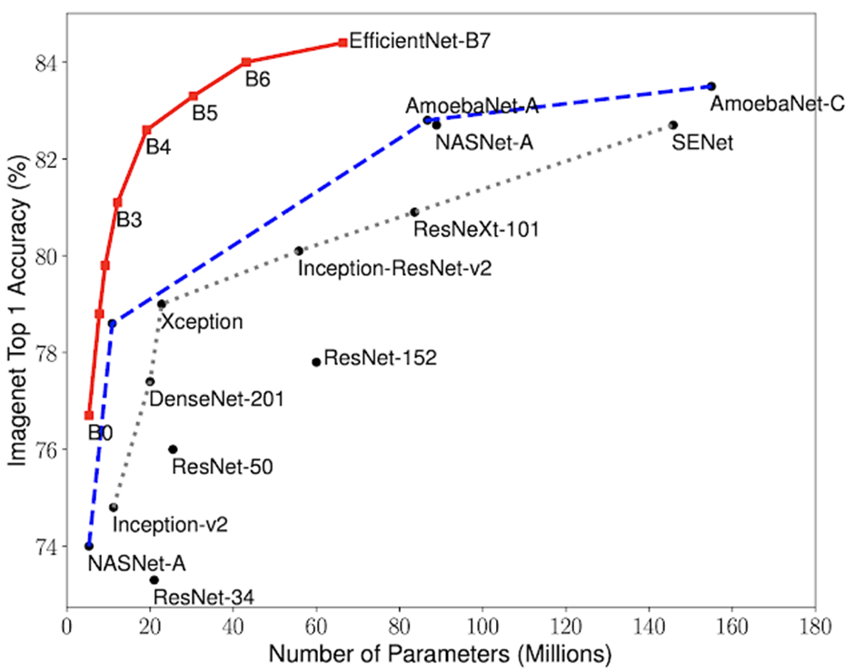The architecture for our baseline network EfficientNet-B0 is simple and clean, making it easier to scale and generalize.

Figure : EfficientNet Performance

EfficientNet Performance:  
We have compared our EfficientNets with other existing CNNs on [ImageNet](http://www.image-net.org/). In general, the EfficientNet models achieve both higher accuracy and better efficiency over existing CNNs, reducing parameter size and FLOPS by an order of magnitude. For example, in the high-accuracy regime, our EfficientNet-B7 reaches state-of-the-art 84.4% top-1 / 97.1% top-5 accuracy on ImageNet, while being 8.4x smaller and 6.1x faster on CPU inference than the previous [Gpipe](https://arxiv.org/abs/1811.06965). Compared with the widely used [ResNet-50](http://www.arxiv.org/abs/1512.03385), our EfficientNet-B4 uses similar FLOPS, while improving the top-1 accuracy from 76.3% of ResNet-50 to 82.6% (+6.3%).

Model Size vs. Accuracy Comparison. EfficientNet-B0 is the baseline network developed by [AutoML MNAS](https://ai.googleblog.com/2018/08/mnasnet-towards-automating-design-of.html), while Efficient-B1 to B7 are obtained by scaling up the baseline network. In particular, our EfficientNet-B7 achieves new state-of-the-art 84.4% top-1 / 97.1% top-5 accuracy, while being 8.4x smaller than the best existing CNN.

Though EfficientNets perform well on ImageNet, to be most useful, they should also transfer to other datasets. To evaluate this, we tested EfficientNets on eight widely used transfer learning datasets. EfficientNets achieved state-of-the-art accuracy in 5 out of the 8 datasets, such as [CIFAR-100](https://www.cs.toronto.edu/~kriz/cifar.html) (91.7%) and [Flowers](http://www.robots.ox.ac.uk/~vgg/data/flowers/) (98.8%), with an order of magnitude fewer parameters (up to 21x parameter reduction), suggesting that our EfficientNets also transfer well.

**3.8 Conclusion**

The methodology followed in the project work is the outcome of the research work carried out in the company. The research work carried out to identify the methodology included journal papers, conference paper, articles published by the industry people, websites related to the solar PV technology to track the solar related information, videos published by the industry experts. The tools used to create web application was proposed by the company director. The methodology process is simple but effective results are established through it. The methodology followed requires large various distinct parameters of the solar PV system and diverse Machine Learning models. Dataset cleaning and analysis is given more importance in the methodology followed in the research work. The above formulas mentioned are used in our project work but among its capacity factor, availability related parameters are not used in the project work done till now and can be used for upcoming project work. Except the few parameters ret all the formulas are included in the project work for various calculation and for prediction models used like inverter efficiency, tilt angle calculation etc.

**CHAPTER 4**

**RESULT ANALYSIS**

**4.1 Introduction**

The various dataset used in implementing the methodology of the project is mentioned in this chapter. Simple and understanding graphs obtained by the analysis carried out for the dataset and results of various models are explained. Images of the Web application developed are added in the chapter.

**4.2 Dataset Analysis**

The Initial data given contains dataset of solar power generation and sensor data for two power plants located in INDIA. Each plant has a pair of datasets related to their respective power generation and various sensor’s data. The power generation Data consist of AC and DC power generated at the inverters end, which is connected to n number of panels. There are 21 inverters in plant 1 and 22 inverters in plant 2 having unique inverter id called as source key. Each plant consists of various weather senser and required parameters are noted down.



Figure 26: Parameters of the initially given plant generation data



Figure 27: Parameters of the initially given plant weather data

The next Data received contained solar Energy Generation and Consumption in $\left(kwh\right)$ for 25 different sectors with different PPA rates for a period of 31 days in the month of January having time interval of 10min from 7am to 7pm. The data given also contained generation losses and consumption losses in Rupees $(Rs$). The generated solar energy was distributed to Hospitals, Hotels, Industries, Offices & Malls equally even though the generation is varying throughout the Day.



Figure 28: Parameters of the solar pv system given by the company

Later to the given data various parameters were added by the AI team and started the Data prepossessing step. The below mentioned parameters were combined to the given data, and analysis was started. The models proposed required a greater number of datasets to proceed with the analysis the AI team came up with these datasets which contained meteorologic data parameters.

Table 2: Additional dataset used for various calculation in the project

|  |  |  |
| --- | --- | --- |
| **Sl no.** | **Parameter** | **Measuring Unit** |
| 1 | Temperature | $$℃$$ |
| 2 | Humidity | % |
| 3 | windspeed | $$Kmph$$ |
| 4 | Precipitation | $$mm$$ |
| 5 | Cloud cover | % |
| 6 | Sunrise | Time |
| 7 | Dewpoint | $$℃$$ |
| 8 | AQI | Real no. (R) |
| 9 | wind-dir. | $°$ (degrees) |
| 10 | Pressure | $$mm$$ |
| 11 | visibility | % |
| 12 | Sunset | Time |
| 13 | Moonrise | Time |
| 14 | Moonset | Time |
| 15 | Wind-chill | $$℃$$ |
| 16 | Feels Like | $$℃$$ |
| 17 | Heat Index | $$℃$$ |
| 18 | Wind-Gust | $$Kmph$$ |

**4.3 Result analysis:**

The results obtained for the given dataset by implementing the Data analysis process carried out in the project work is presented in the form of various graphs and charts. Results obtained by various machine learning models and data visualization done by using Mat2plotlib library of python in the form of table/one line sentence are mentioned.

Azimuth Angle

The azimuth angle is the compass direction from which the sunlight is coming. At solar noon, the sun is always directly south in the northern hemisphere and directly north in the southern hemisphere. The azimuth angle varies throughout the day as shown in the animation below. At the equinoxes, the sun rises directly east and sets directly west regardless of the latitude, thus making the azimuth angles 90° at sunrise and 270° at sunset. In general, however, the azimuth angle varies with the latitude and time of year and the full equations to calculate the sun's position throughout the day are given on the following page.

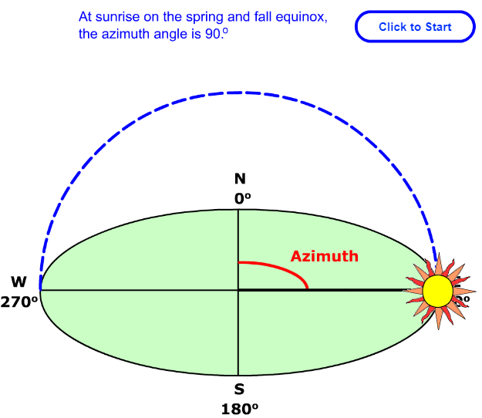

Figure 29: Azimuth angle is like a compass direction with North=0° & South= 180°

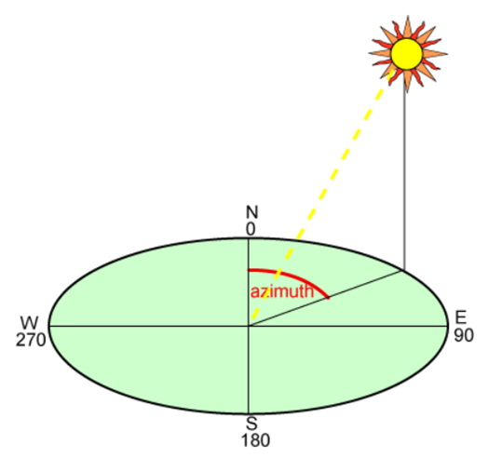

Figure 30: AZIMUTHAL ANGLE CALCULATIONS From South side

* Wrote one function to put all the calculations in one form

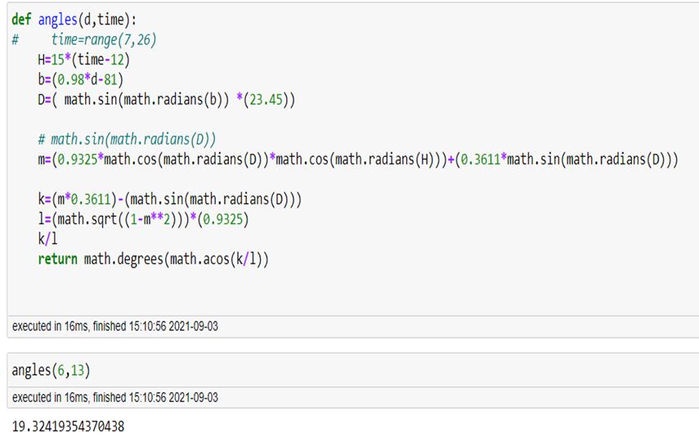

Figure 31: Code for Azimuthal Angle

* Manually checked all the values and find the values of Azimuthal angle to be same
* Plotted the azimuthal angle with respect to other predictors in our

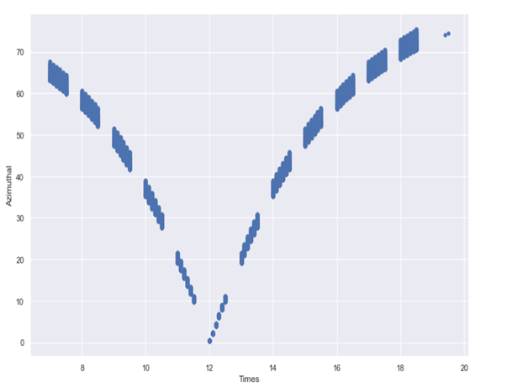

Figure 32: Azimuthal vs Time of the Day

* Clearly Visible Azimuthal angle approaches 0 degree at 12 noon.
* Energy generation is inversely proportional to azimuthal angle as per our analysis.

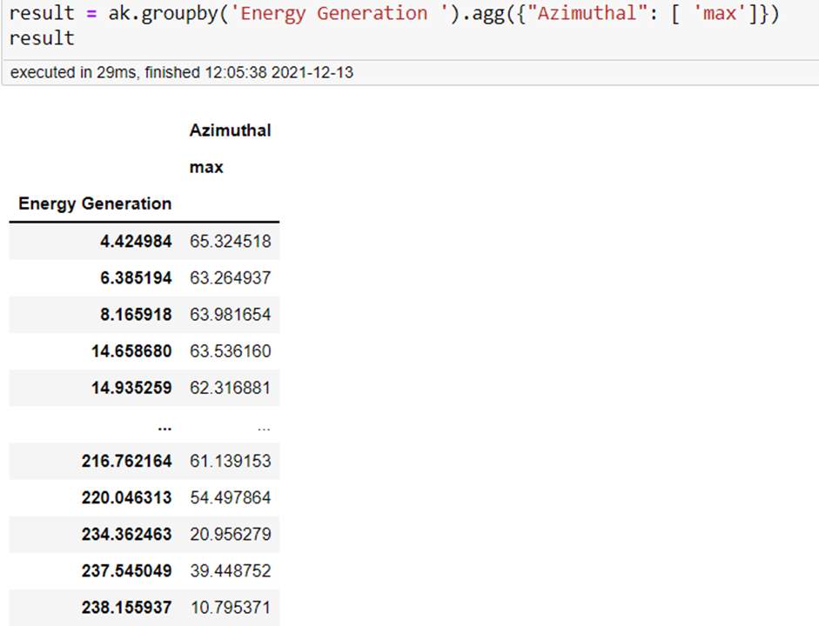

Figure 33: Relationship of the Energy Generation and Azimuth angle

The figure 34 represent the AC Power output of the individual inverters. Each inverter is named after one unique Source Key and the AC power in $kW$ is measure at the inverter output side by multifunction meter or inbuilt inverter measuring equipment. By the graph we can identify if there is any fault by checking AC Power output of every inverter. By the visual representation it would be easier to understand the working of any equipment. By setting a standard lower limit value for all the inverter one can identify the underrated performing inverter if the inverter is producing lesser to the standard set value.

The figure 36 represent the inverter efficiency at a particular time of the day. Here we can analyze how good is the inverter performing in a particular day. In the graph we can see that the efficiency is decreasing at a period 12pm to 1pm, the reduced efficiency is noted down and error would be rectified. By creating this kind of representation of the inverters efficiency one could identify the underperforming inverter earlier and prevent losses.

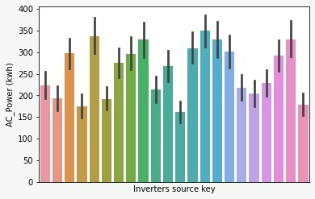

*Figure 34: AC power generated (kwh) per day by different Inverters*



Figure 35: Code for calculating the total number of inverters

The figure 37 represents amount of power waste in a particular day of the year. In the graph we can see that there is a very high loss on 31st of Jan. with the help of this graphs we can identify a pattern of how the system works and depending on the Pattern we can predict the future values which helps in identifying the fault in a PV system. it’s a running graph and it is for the month of January.

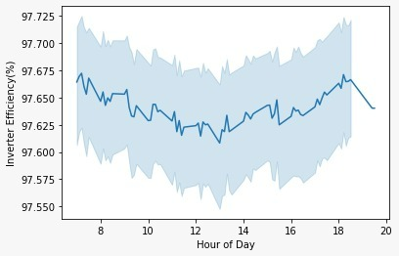

*Figure 36: variation of Inverter efficiency (%) during the daytime*

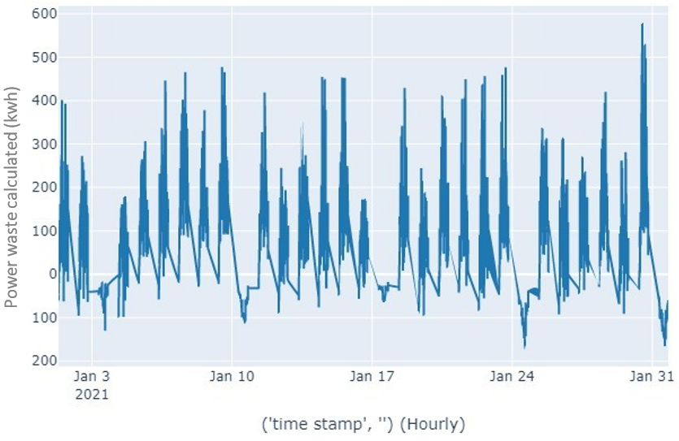

*Figure 37: Power waste calculated (kwh) per hours for January month*

The figure 38 represents the amount of carbon dioxide saved by the solar PV plant in a particular day. The formulas used for calculating the carbon saving is considered as for every 1 kw generated carbon saved will be addition of 0.94 kg of carbon saving. of This kind of representation helps in keeping track of amount of carbon saving done by the solar PV plant.

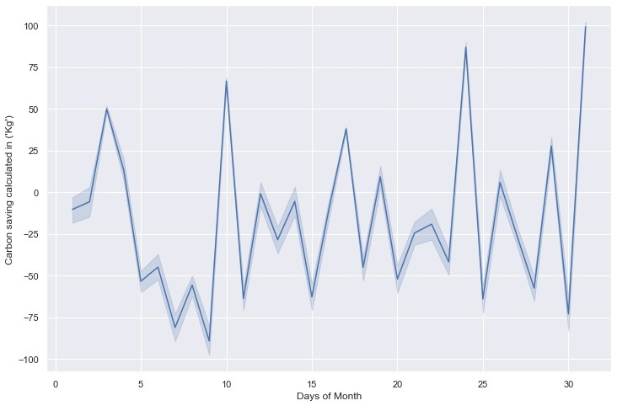

*Figure 38:Carbon saving calculated in (kg) per day for a month*

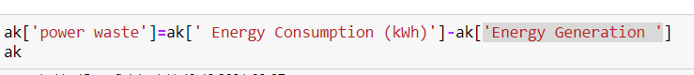

Figure 39: Code for calculating Power Waste

The figure 40 represents the prediction of the total power waste verses number of days and almost the predictions are equivalent to the recorded value. This kind of work will be helpful in balancing or fulfilling the demand load. Even by predicting various other parameters one can prevent the losses and operate the plant in more efficient ways.

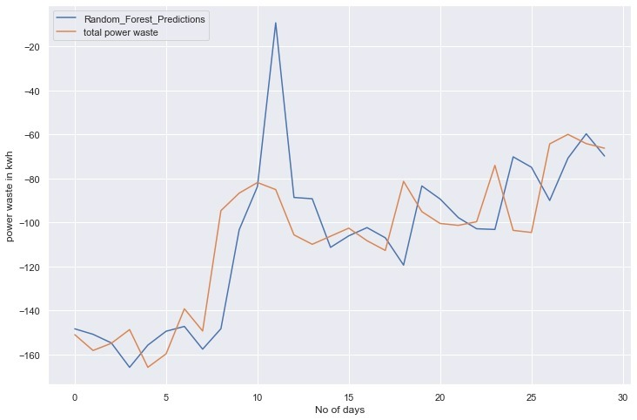

*Figure 40: Predictions of power waste (kwh) per day for a month*

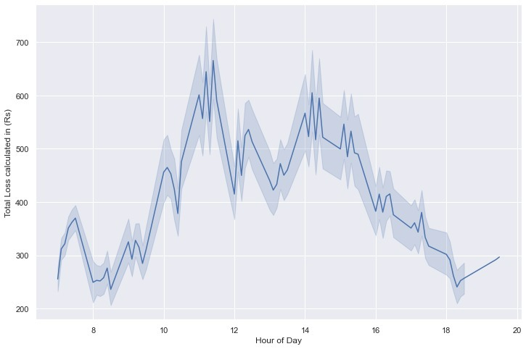

*Figure 41: Total power loss calculated in (Rs) per hour during daytime*

The figure 41 represents the total amount in rupees loss occurred in a particular time of the day. The energy generated is not being utilized properly by the consumers and the power generated are being wasted. Here in this graph one can observe there is a high loss in the afternoon section and will be noted down & presented to the plant operator.

The figure 42 represents the inverter efficiency and density of the solar PV plant for the data that was initially given by the company. Only fewer graphs and charts were able to extract from the initial data given by the company. Density is high then that they are used highly. For a group of inverters how much % of efficiency is recorded most of the time

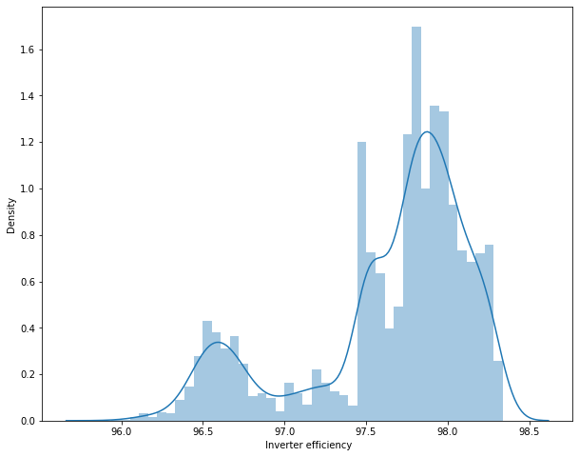

Figure 42: Histogram plot of inverter efficiency

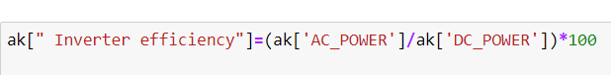

Figure 43: Code for calculating Inverter Efficiency

The figure 44 represents number of peak sun hour available for a particular day of a month. By analyzing the visual graph, on 20th day of the month is recorded the highest sun peak hour and there is a variation in the sun peak hours throughout the month. one peak sun-hour is equal to one hour of sunlight which is 1000 $w/m²$ is being received in one day. By this kind of visualization one can easily identify the reason for low power generation and many other useful information.

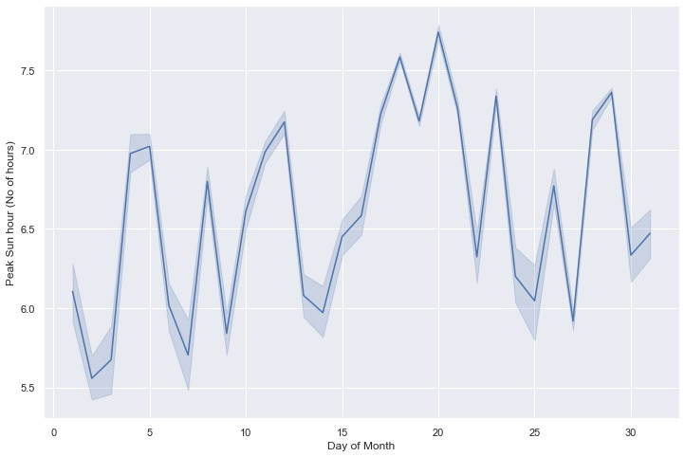

*Figure 44: Number of Peak sun hours received per day for one month*

The figure 45 & figure 46 represents the Irradiation received throughout the day at a particular location by both the solar photovoltaic plants named Plant 1 & Plant 2.

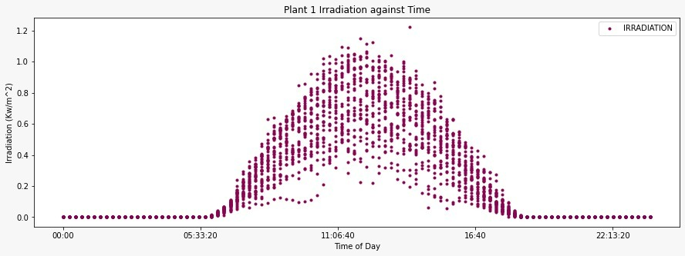

*Figure 45: Irradiation $kw/m^{2}$ received by plant 1 for a month*

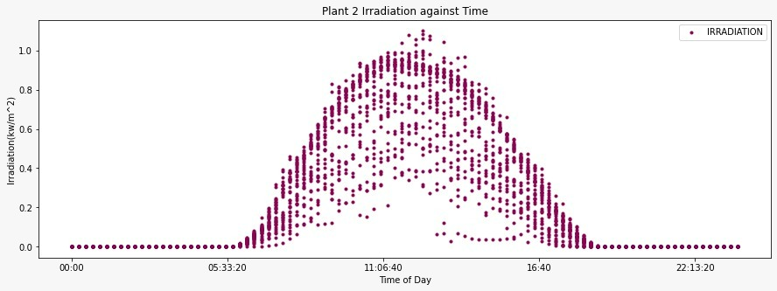

*Figure 46: Irradiation $kw/m^{2}$ received by plant 1 for a month*

The Irradiation gradually increases around 6 am-7am to noon 12 am receiving the highest Irradiation value later it starts decreasing till around 6 pm. The highest recorded Irradiation by Plant 1 is 1.22 $kw/m^{2}$& the highest recorded Irradiation value by Plant 2 is 1.098766043 $kw/m^{2}$.

The figure 47 & figure 48 represents the Ambient Temperature recorded throughout the day by both the solar PV plants named Plant 1 & Plant 2. The plant 1 is having lower temperature when compared to Plant 2. The highest recorded Ambient temperature by plant 1 is 35.25248613 $℃$& the highest recorded Ambient temperature by plant 2 is 39.18163777 $℃$ and the lowest value recorded value is 20.39 $℃$& 20.94 $℃$ respectively. By this kind of graphical representation one can easily understand the performance of solar photovoltaic power plant by representing various distinct parameters available that could be extracted from the power plant. These are few graphical representations that was obtained by analyzing the dataset given by the company.

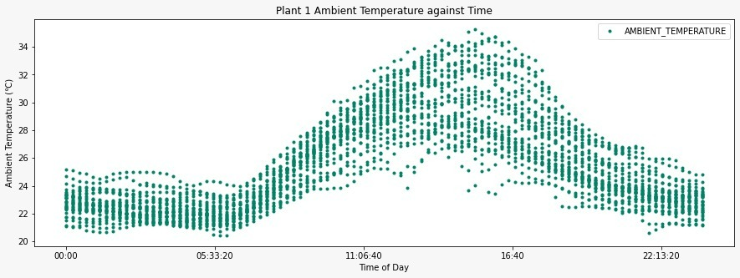

*Figure 47: Ambient temperature in $℃$ received by the Plant 1 for a month*

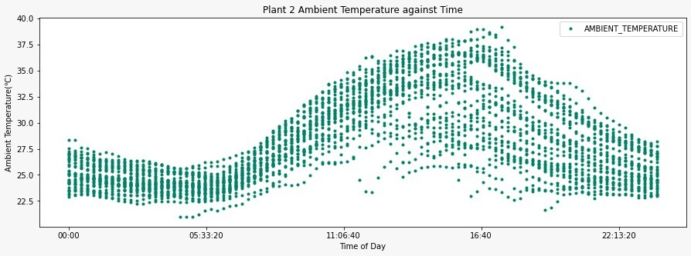

*Figure 48: Ambient temperature in $℃$ received by the Plant 2 for a month*

Table 3: Inverters Source Key and Power Waste calculated

|  |  |  |
| --- | --- | --- |
| **Sl. no** | **Inverter Source Key/inverters ID** | **Power Waste calculated in (Rs)** |
| 1 | 4UPUqMRk7TRMgml | 370.48 |
| 2 | 81aHJ1q11NBPMrL | 453.46 |
| 3 | 9kRcWv60rDACzjR | 462.79 |
| 4 | Et9kgGMDl729KT4 | 497.10 |
| 5 | IQ2d7wF4YD8zU1Q | 477.00 |
| 6 | LYwnQax7tkwH5Cb | 344.95 |
| 7 | LlT2YUhhzqhg5Sw | 476.97 |
| 8 | Mx2yZCDsyf6DPfv | 392.86 |
| 9 | NgDl19wMapZy17u | 406.72 |
| 10 | PeE6FRyGXUgsRhN | 409.59 |
| 11 | Qf4GUc1pJu5T6c6 | 447.71 |
| 12 | Quc1TzYxW2pYoWX | 404.09 |
| 13 | V94E5Ben1TlhnDV | 330.52 |
| 14 | WcxssY2VbP4hApt | 420.31 |
| 15 | mqwcsP2rE7J0TFp | 456.84 |
| 16 | oZ35aAeoifZaQzV | 454.34 |
| 17 | oZZkBaNadn6DNKz | 528.16 |
| 18 | q49J1IKaHRwDQnt | 449.67 |
| 19 | rrq4fwE8jgrTyWY | 486.67 |
| 20 | vOuJvMaM2sgwLmb | 418.70 |
| 21 | xMbIugepa2P7lBB | 576.56 |
| 22 | xoJJ8DcxJEcupym | 392.60 |

Table 4: Inverter Efficiency with source key

|  |  |  |
| --- | --- | --- |
| **Sl. no** | **Inverter Source Keys/inverters id** | **Inverter efficiency (%)** |
| 1 | 4UPUqMRk7TRMgml | 96.10 % |
| 2 | 81aHJ1q11NBPMrL | 96.15% |
| 3 | 9kRcWv60rDACzjR | 96.19% |
| 4 | Et9kgGMDl729KT4 | 96.32% |
| 5 | IQ2d7wF4YD8zU1Q | 96.09% |
| 6 | LYwnQax7tkwH5Cb | 96.34% |
| 7 | LlT2YUhhzqhg5Sw | 96.36% |
| 8 | Mx2yZCDsyf6DPfv | 96.12% |
| 9 | NgDl19wMapZy17u | 96.01% |
| 10 | PeE6FRyGXUgsRhN | 96.14% |
| 11 | Qf4GUc1pJu5T6c6 | 96.24% |
| 12 | Quc1TzYxW2pYoWX | 96.15% |
| 13 | V94E5Ben1TlhnDV | 96.10% |
| 14 | WcxssY2VbP4hApt | 96.26% |
| 15 | mqwcsP2rE7J0TFp | 96.16% |
| 16 | oZ35aAeoifZaQzV | 96.28% |
| 17 | oZZkBaNadn6DNKz | 96.08% |
| 18 | q49J1IKaHRwDQnt | 96.19% |
| 19 | rrq4fwE8jgrTyWY | 96.12% |
| 20 | vOuJvMaM2sgwLmb | 96.27% |
| 21 | xMbIugepa2P7lBB | 96.19% |
| 22 | xoJJ8DcxJEcupym | 95.94% |

**Prediction with respect to Linear Regression:**

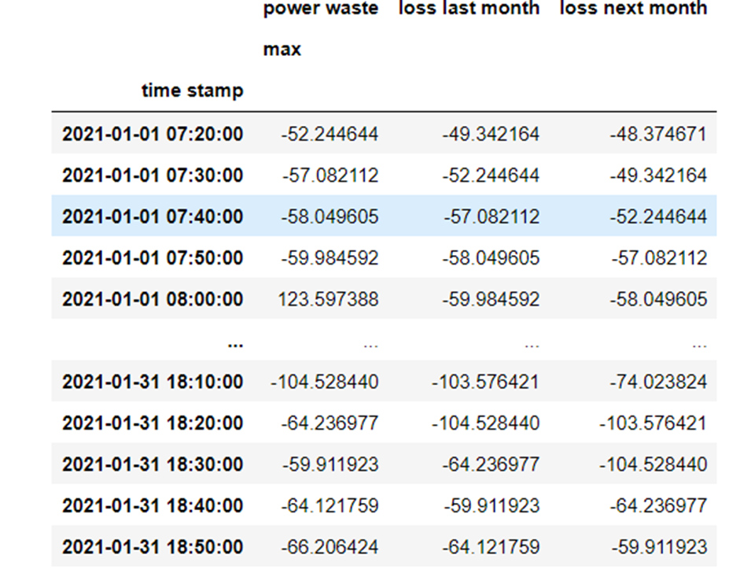

Figure 49: Prediction of Power waste w.r.t time

By observing the above table one can observe that **xMbIugepa2P7lBB** is the inverter which is giving highest power loss.

The inverter inception will be conducted or with the help of the data analysis only the cause for the high loss could be identified.

The below table 3 represents the inverter efficiency of different inverters which have unique source key for reach one of the inverters separately. The efficiency of the inverter recorded are above average level and are working in very good condition. The figure 50 is representing the Prediction of the power waste, which is measured in kwh, as clearly visible on 10th day random forest predicts higher loss.

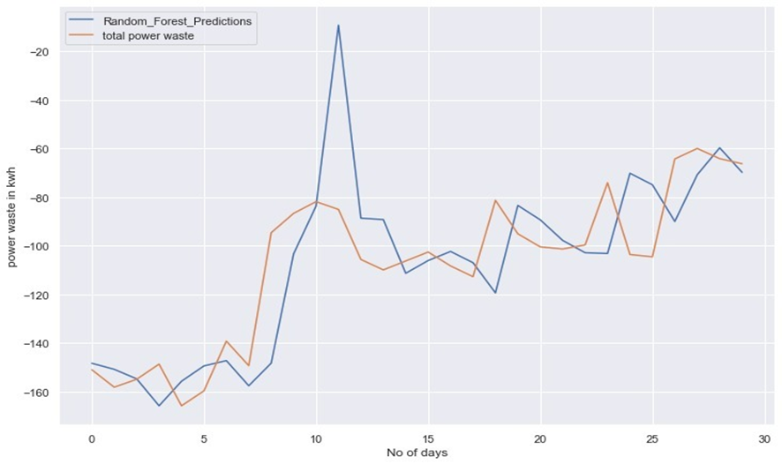

Figure 50: Random Forest prediction of power waste w.r.t number of days

**Prediction with respect to LSTM Regression:**

**Predictions in Data**

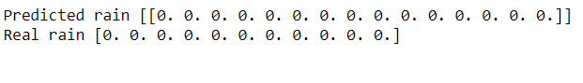

Figure 51: Rain fall Prediction for next 15 days

* The rain predictions clearly mention that there will be no rain in upcoming days.

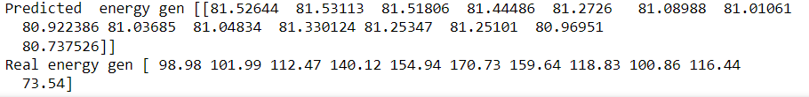

Figure 52: Energy generation prediction for next 15 days

* There are certain changes for energy generations might be because of fault.

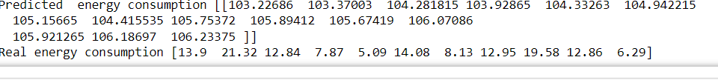

Figure 53: Energy Consumption prediction for next 15 days

* There is large gap between predicted and Real energy consumptions.

**Predictions of EROI using Lstm**

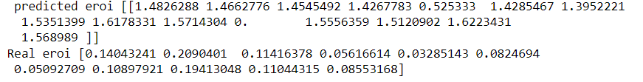

Figure 54: EROI prediction for next 15 days

**4.5 Image processing and outcomes**

For image processing analysis the dataset received contained around 45 thousand images which included soiled, cleaned-good images of solar modules. Among the received dataset 400 cleaned-good images and 400 soiled images of solar modules was manually selected and used in the analysis. 160 images were used for testing or considered as test data and 640 images was used for training the models called train data.

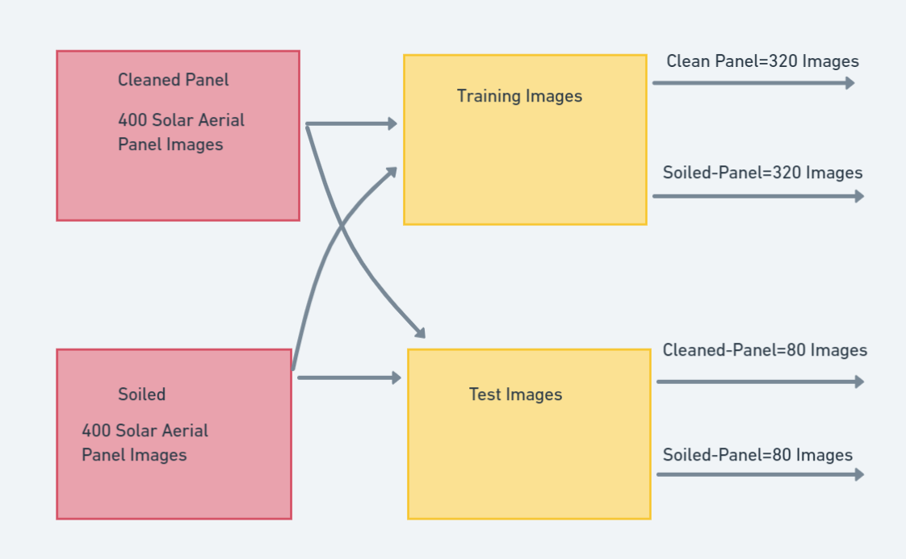

Figure 55: Block Diagram of Folder Structure

**Output results for Resnet50**:

The Result were pretty good on the ImageNet validation set, The ResNet 50 model achieved a top-1 error rate of 20.47 percent and achieved a top-5 error rate of 5.25 percent, this is reported for single model that consists of 50 layers not a ensemble of it. below is the table given if you want to compare it with other ResNets or with other models.

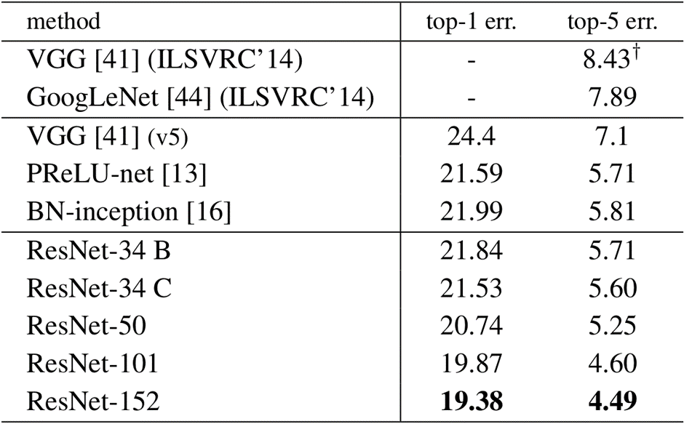

Figure 56: list of models and their error percentage

**Uses**

This architecture can be used on computer vision tasks such as image classification, object localization, object detection.

and this framework can also be applied to non-computer vision tasks to give them the benefit of depth and to reduce the computational expense also.

**Key Advantage**

By using residual blocks in the network, one can construct networks of any depth with the hypothesis that new layers are helping to learn new underlying patterns in the input data. The authors of the paper were able to create the deep neural network architecture with 152 layers. The variants of Resnets such as resnet34, resnet50, resnet101 have produced the solutions with very high accuracy in ImageNet competitions.

**Why it works?**

Let’s discuss why residual networks are successful and enables the addition of more and more layers without the key problems i.e., without hurting the network performance.

Consider a plain neural network (A) without residual network as shown. So, in the network (A) the input X is passed to this Neural Network (NN) to give the activation A1.

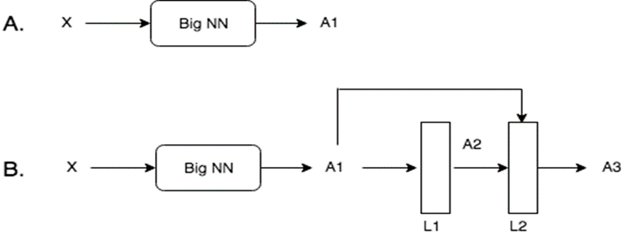

Figure 57: Basic diagram of Resnet

Now, consider a deeper network (B) in which a residual block (with 2 extra layers and a skip connection) is added in the previous network. So now, the activation A1 is being passed to Residual Block which in turns gives new activation A3.

if there was no skip connection, then A3 was:

A3 = relu (W2. A2 + b2) ..... (Without skip connection)

where W2 and b2 are weights and bias associated with layer L2. But, with skip connection another term A1 will be passed to L2. So, the equation of A3 will be modified as:

A3 = relu (W2. A2 + b2 + A1)

If we use L2 regularization or the weight decay methods, they will force W2 and b2 to become close to zero. In the worst case, if these become zero, then

A3 = relu (A1)

because relu will output 0 for negative, A1 for positive and we know that A1 is previous activation from relu which is positive.

A3 = A1

This means that Identity function is easy for residual blocks to learn. By addition of residual blocks, model complexity was not increased. As this is only copying the previous activation to the next layers. However, this is only the worst-case situation, but it may turn out that these additional layers learns something useful. In that case, the network performance will improve.

Hence, adding the residual blocks / skip connections does not hurt the network performance but in fact increases the chances that new layers will learn something useful.

Let's look at the usage using pre-trained Resnet 50 model.

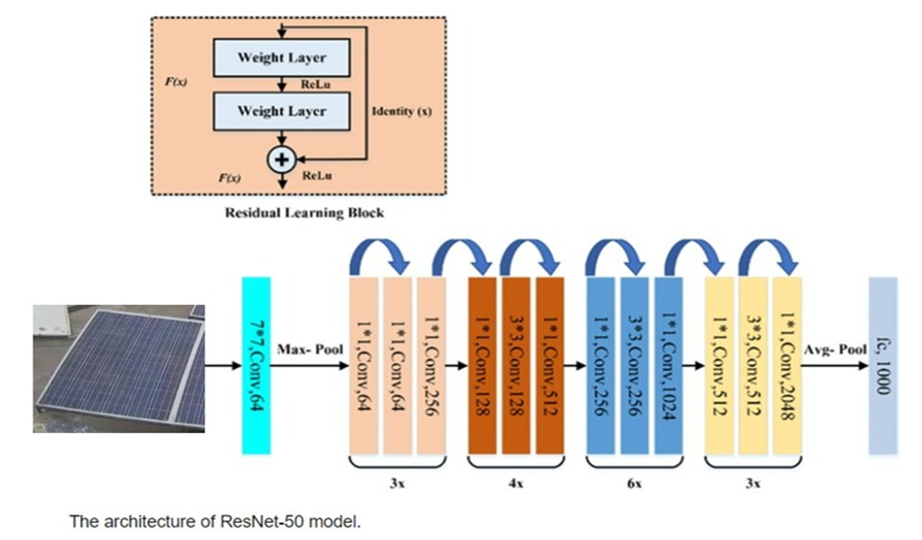

Figure 58: Architecture of Resnet 50

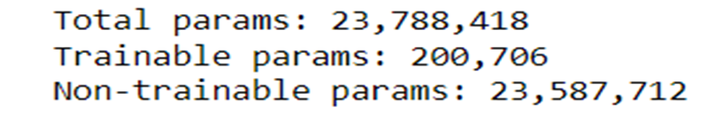

Figure 59: Parameters of Resnet 50

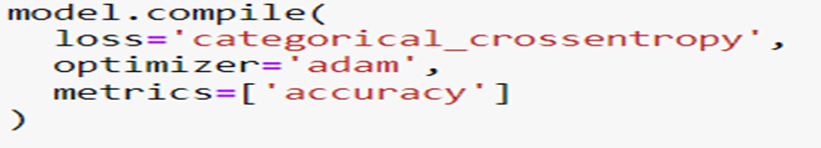

Figure 60: Details of the Model training

**Results-** loss: 0.0264 - accuracy: .9750 - val_loss: 0.0601 - val_accuracy: 0.9875

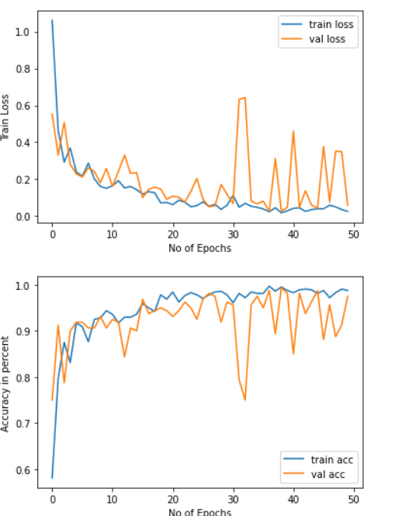

Figure 61: Plot of Number of Epochs vs Train Loss & Val Loss

**Plot of Number of Epochs vs Train Loss & Val Loss**

Figure : Saving the model to build flask Application

**Output results for VGG-16:**

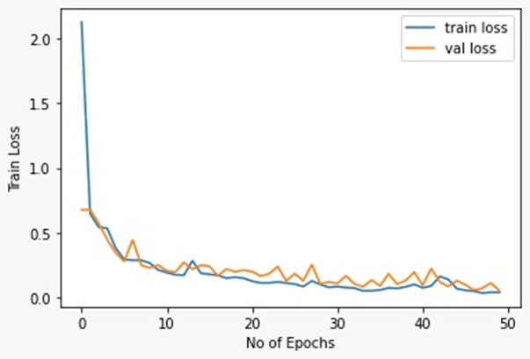

Figure 63: Training loss w.r.t number of epochs (VGG 16)

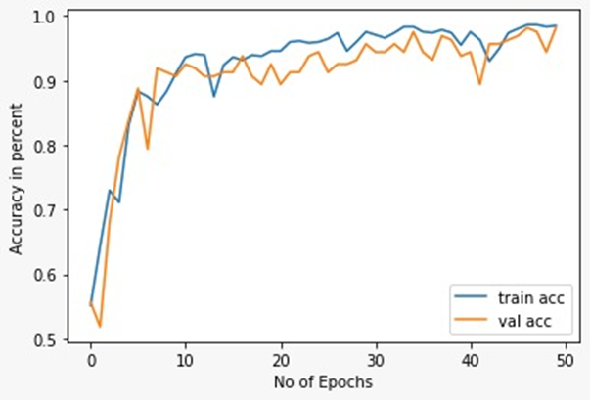

Figure 64: Efficiency w.r.t number of epochs (VGG 16)

**Output results for VGG-19:**

loss: 0.0604 - accuracy: 0.9781 - val_loss: 0.1113 - val_accuracy: 0.9750

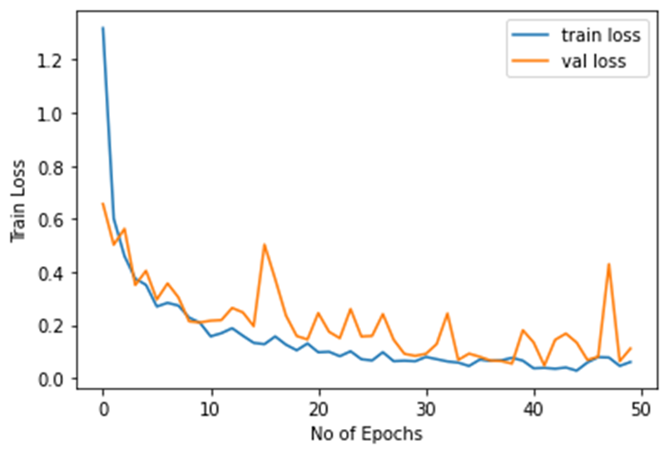

Figure 65: Training loss w.r.t number of epochs (VGG 19)

**Output results for Inception v3:**

loss: 0.0357 - accuracy: 0.9844 - val_loss: 0.0449 - val_accuracy: 0.9875

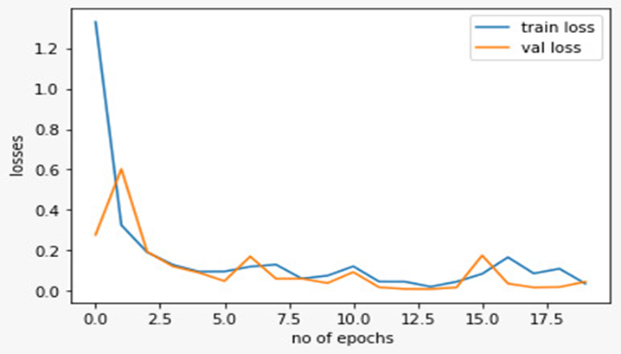

Figure 66: Efficiency w.r.t number of epochs (VGG 19)

**Output results for** **EfficientNet-b0:**

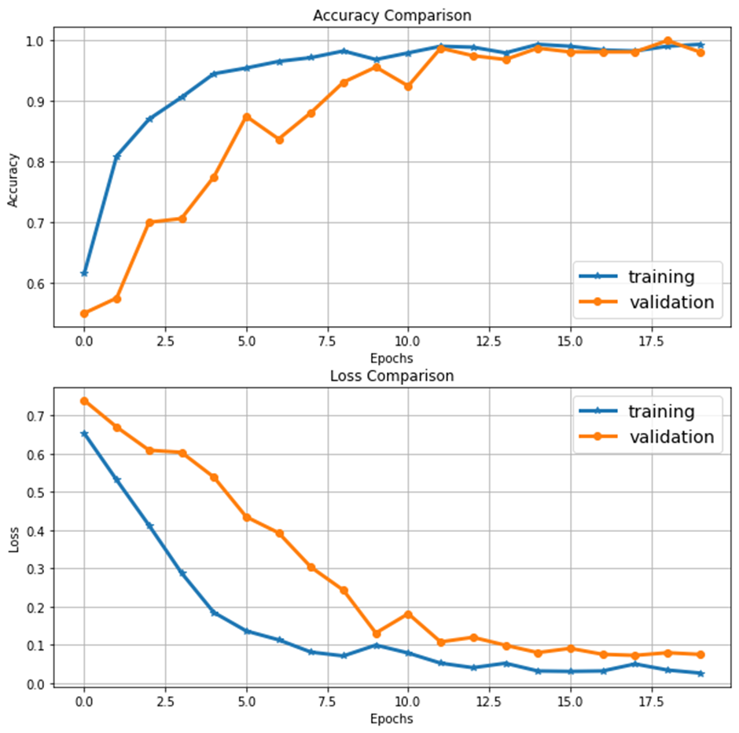

Figure 67: Efficiency and Loss w.r.t number of epochs (EfficientNet-b0)

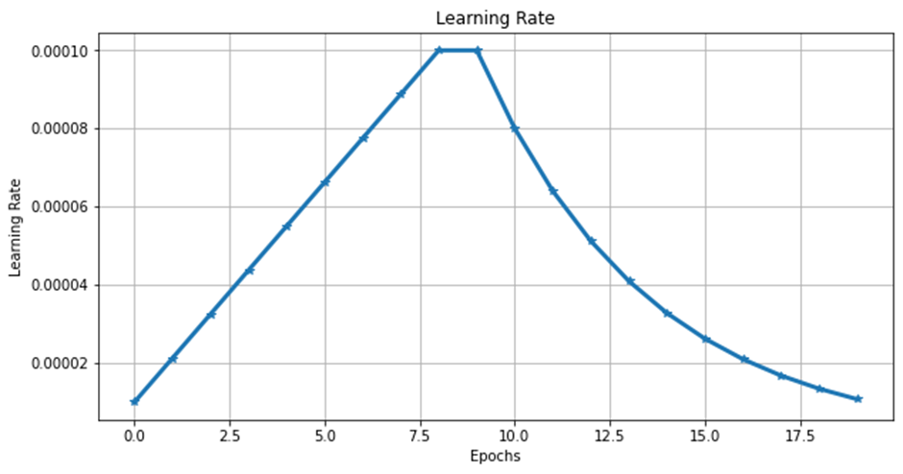

Figure 68: learning rate w.r.t number of epochs

**Auc Curve:**

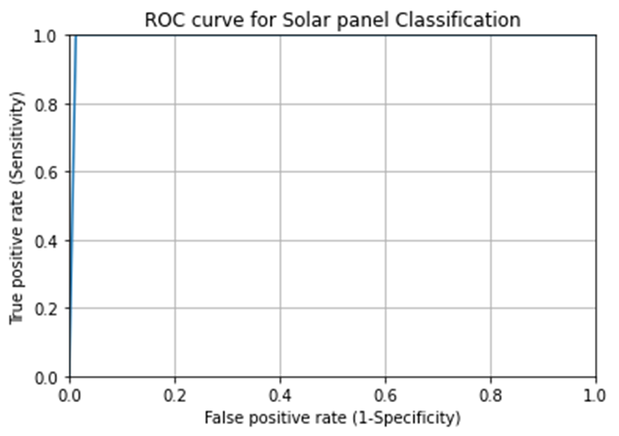

Figure 69: ROC curve for solar panel classification

The higher the AUC, the better the performance of the model at distinguishing between the positive and negative classes. When AUC = 1, then the classifier is able to perfectly distinguish between all the Positive and the Negative class points correctly.

**4.4 Sample Web application Created**

The below figure 70 show the sample web application that is created using Django framework in which included the work on collecting the formula required for calculation. In this application we are predicting the possible system loss that could happen by analysing the data given to us by the company. The model creates a pattern among the available data by corelating the different parameters available in the dataset. Then by analysing the given input the model predicts the possible outcome depending on the pattern it has identified. Here in our case, prediction of the total loss of the system in rupees is proposed by considering 4 different parameters as input. The figure 24 represents that the system is having high loss for the values entered in different input parameters. Later this Web application was included in the main Web application of the project which include different tabular column & subpages.

The below listed figures are the sample image dataset used in training the Machine learning model. The figures 72,73 and 76 are the images used for testing the models.

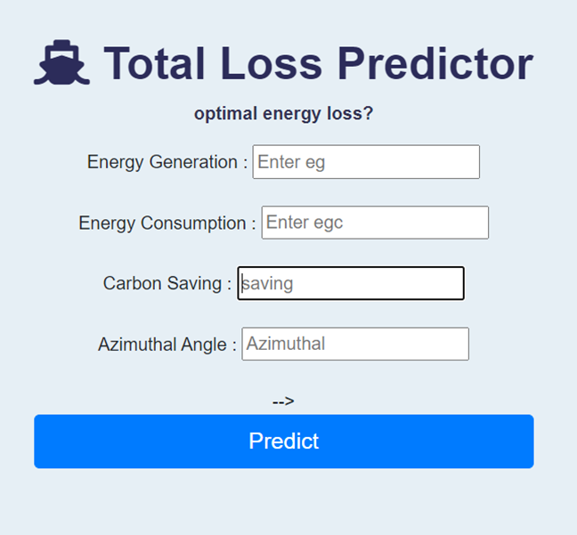

Figure 70: Sample Web application Created



Figure 71: Result Obtained from the Web application Created

The figure 72 is a clean good solar panel image used for testing which is chosen within the trained data. The figure 73 is a soiled image is the solar panel used for testing and this image is taken from open source and not from the training image dataset. The figure 76 is also a soiled image and is taken from opensource. The other two images used are selected for trailing the machine learning models. The figure 74 is a good cleaned solar pane image and figure 75 is a soiled image.

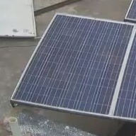

Figure 72: Image no.1 used for testing

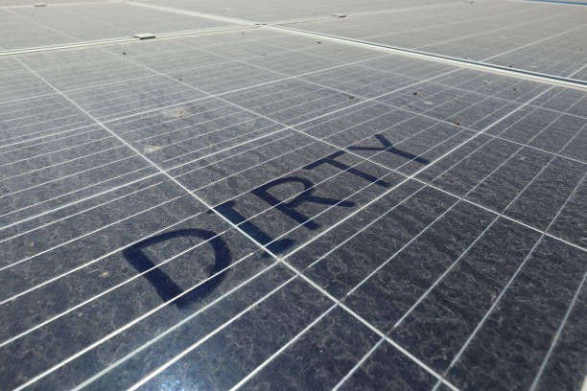

Figure 73: Image no.2 used for testing



Figure 74: Good clean image used in training the model

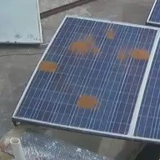

Figure 75: Soiled image used in training *the model*

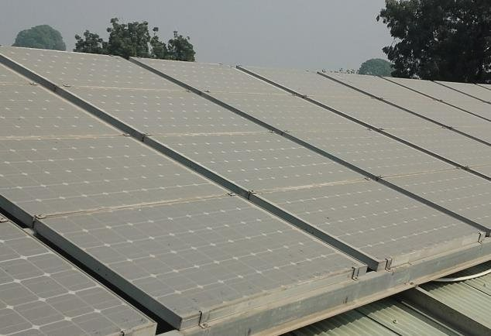

Figure 76: Image no.3 used for testing

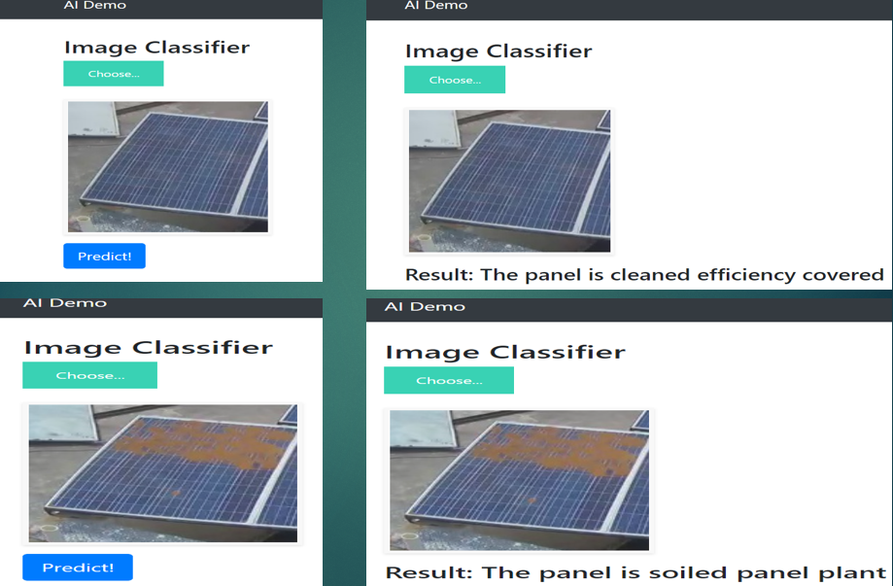

Figure 77 basic Demo of Flask Result

**4.5 Adam Optimizer Gradient Descent:**

This algorithm is used to accelerate the gradient descent algorithm by taking into consideration the 'exponentially weighted average' of the gradients. Using averages makes the algorithm converge towards the minima in a faster pace.Metrics**,** Categorical cross entropy is a loss function that is used in multi-class classification tasks. These are tasks where an example can only belong to one out of many possible categories, and the model must decide which one. Formally, it is designed to quantify the difference between two probability distributions.

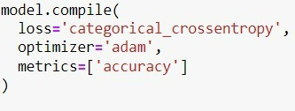

Figure 78: Metrics used in the ML Models



Figure 79: Front page of the web application

**4.6 Significance of The Results and conclusions**

The results obtained in this research work contains error in few of the analysis. The errors occurred are considered as important and worked on improving the results. The errors occurred in the process of analysis is rectified and rest of the analysis is giving correct outcome. A web application not fully developed has not yet deployed. All the results in the form of graph and various charts mentioned in the research work was conducted for the dataset given by the company.

The table 5 represents the various parameters of the CNN architecture used in this project. All the architecture used are giving good efficiency both training and as well as validation. If one must be considered it would be inception v3 architecture which is giving us high validation accuracy with minimum number of epochs. Epochs is the number of times the architecture has gone through the training dataset. Even with minimum number of epochs the architecture can identify more than 21 million parameters among which only 102,402 parameters are trainable. But the resnet 50 is having little lower validation accuracy than the training accuracy and was able to identify more than 23 million parameters among which only 20,0706 parameters are trainable.

Table 5: Comparison of Five different CNN architectures considered in this project

|  |  |  |  |  |  |  |  |
| --- | --- | --- | --- | --- | --- | --- | --- |
| **Sl. no** | **CNN Architecture** | **Training Accuracy** | **Validation Accuracy** | **No. of Epochs** | **No. of Parameters** | **Trainable parameters** | **Non-trainable parameters** |
| **1** | Resnet 50 | 97.50%% | 98.75% | 50 | 25,100,046 | 25,100,046 | 0 |
| **2** | VGG 16 | 98.44% | 98.12% | 50 | 14,714,688 | 14,714,688 | 0 |
| **3** | VGG 19 | 97.81% | 97.50% | 50 | 20,024,384 | 20,024,384 | 0 |
| 4 | Inception v3 | 98.44% | 98.75% | 20 | 21,905,186 | 102,402 | 21,802,784 |
| 5 | EfficientNet-bo | 99.69% | 98.75% | 20 | 4,050,845 | 4,008,829 | 42,016 |

Outcome of the deep learning models/CNN Architecture:

* Identify the solid panel which is the major reason for low power generation.
* Formation of Hot spot will be prevented.
* The human power will be reduced in site inception for regular maintenance.
* Low power generation lead to plant underperformance, and it can be prevented.
* Maintenance cost can be reduced.
* Return on investment can be increased.
* Resnet 50 and Inception v3 both are giving very good validation accuracy and they have been trained on large number of parameters.

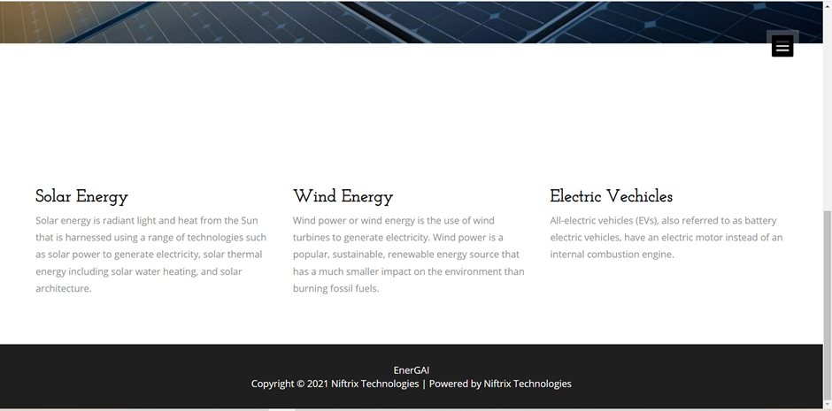

Figure 80: lower part of the front web application

All the graphs and prediction models are producing positive value outcome and are finalised to be added to the main web application. The obtained results are as expected since we considered a smaller dataset and did not contain all the required parameter to validate the results or to record the percentage of efficiency. The validation part is pending science we did not collect the real-time data or a data of a particular plant. Even though validation part is not fulfilled but the various models used for Data Analysis is performed and results are obtained. This chapter included all the various outcomes of the ML models proposed in identifying the losses in the system.

The figure 78 represents the home page of the web application that is considered as part of the objective. The web application is not specific to solar PV system only but also considered other renewable energy sources. The lower part of the web application’s home page is covered with definition of the different sectors of renewable. the figure 79 represent the lower part of the home page of the web application. The figure 80 represents the different tabs included in the web application. There are totally two tabs for now which was approved by the director to add the total loss prediction model and another one was the image processing models. The figure 81 represents the prediction total loss prediction model, by entering four different values of the dataset the plant losses will be identified.

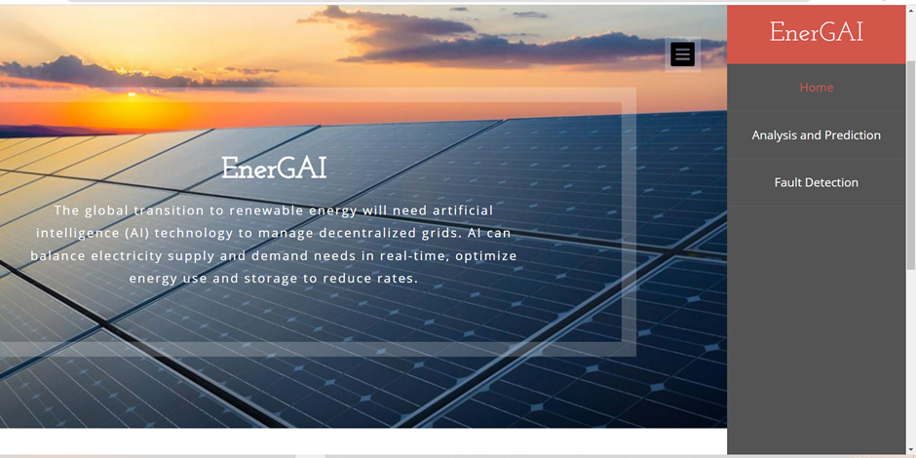

Figure 81: Different tabs incorporated in the web application

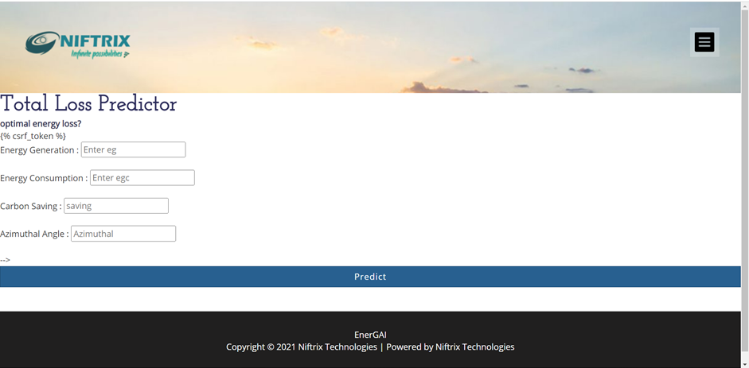

Figure 82: The sample application proposed is integrated to the main web application

**CHAPTER 5**

**CONCLUSIONS & FUTURE SCOPE OF WORK**

**5.1 Conclusions**

The research work carried out, topic discussed, and various models proposed will all lead to encourage the use of renewable energy and increase the share of solar pv energy in the overall electricity share. The methodology followed is satisfying and results are obtained as expected. The research work carried out in the company leaded to the methodology that is being followed in research work. This project can be segregated into different sectors and considering the methodology it requires a large amount of data and computer analytical power to analyse it. The data pre-processing step is very important and must be conducted in the order to get excellent results or outcomes from various models utilized in the research work. Since the data considered in this research work is not matchable to the require parameter the whole ideologies and different concepts discovered was not able to be implemented /validated in the research work.

In this project as per the objective mention various kinds of the running-graph, charts which is easy understanding and time saving. With visual dashboard of various parameters of pv system one can easily identify the root cause of underperformance of a plant during the plant operation with the help of data analytics. The parameter forecasting or predictions models used are producing results near to the real time value that is recorded. Since the product is not deployed yet by the company, it would be better to incorporate all the features once and validate it. All thought the results obtained from image processing is having high accuracy and among the three models the inception v3 is the better.

**5.2 Future scope of work**

* To increase the power generation of solar PV system by reducing the various losses that can be identified in soar PV system and to decreasing the operation & maintenance cost of the solar PV system.
* Application of unmanned aerial vehicle (drone) in solar photovoltaic systems to identify various internal damages in the pv module with the help of image processing and other applications

# References

|  |  |
| --- | --- |
| [1] | M. A. Green, "How did solar cells get so cheap?," *Joule,* vol. 3, no. 3, pp. 631-633, 2019. |
| [2] | A. M. García, J. Gallagher, E. Camacho, E. C. Poyato, P. M. Barrios and J. R. Díaz, "Comparing the environmental and economic impacts of on-or off-grid solar photovoltaics with traditional energy sources for rural irrigation systems.," *Renewable Energy,* vol. 140, pp. 895-904, 2019. |
| [3] | A. Youssef, M. El-Telbany and A. Zekry, "The role of artificial intelligence in photo-voltaic systems design and control: A review.," *Renewable and Sustainable Energy Reviews,* vol. 78, pp. 72-79, 2017. |
| [4] | J. Sunil Kr, J. Bilalovic, A. Jha, N. Patel and H. Zhang, "Renewable energy: Present research and future scope of Artificial Intelligence.," *Renewable and Sustainable Energy Reviews,* vol. 77, pp. 297-317, 2017. |
| [5] | "INVEST INDIA," 11 June 2022. [Online]. Available: https://www.investindia.gov.in/sector/renewable-energy. [Accessed 11 June 2022]. |
| [6] | "INVEST INDIA National Investment Promotion & Facilitation Agency," 2022. [Online]. Available: https://www.investindia.gov.in/sector/renewable-energy. [Accessed 1 February 2022]. |
| [7] | U. GUPTA, "PV Magazine INDIA," 2 November 2021. [Online]. Available: https://www.pv-magazine-india.com/2021/11/02/india-commits-to-net-zero-by-2070/. [Accessed 11 June 2022]. |
| [8] | V. Gupta, M. Sharma, R. K. Pachauri and K. D. Babu, "A low-cost real-time IOT enabled data acquisition system for monitoring of PV system," *Energy Sources, Part A: Recovery, Utilization, and Environmental Effects,* vol. 43, no. 20, pp. 2529-2543, 2021. |
| [9] | R. Nassir, L. Barazane, M. Benghanem and A. Mellit, "IoT‐based low‐cost prototype for online monitoring of maximum output power of domestic photovoltaic systems.," *ETRI Journal,* vol. 43, no. 3, pp. 459-470, 2021. |
| [10] | R. Dabou, A. Bouraiou, A. Ziane, . A. Necaibia, N. Sahouane, . M. Blal, S. Khelifi, A. Rouabhia and A. Slimani, "Development of autonomous monitoring and performance evaluation system of grid-tied photovoltaic station.," *International Journal of Hydrogen Energy,* vol. 46, no. 59, pp. 30267-30287, 2021. |
| [11] | M. Adel and S. Kalogirou, "Artificial intelligence and internet of things to improve efficacy of diagnosis and remote sensing of solar photovoltaic systems: Challenges, recommendations and future directions.," *Renewable and Sustainable Energy Reviews,* vol. 143, p. 110889, 2021. |
| [12] | A. Shaheer, A. Ayob, M. S. H. Lipu, . M. H. M. Saad and A. Hussain, "A review of monitoring technologies for solar PV systems using data processing modules and transmission protocols: Progress, challenges and prospects.," *Sustainability,* vol. 13, no. 15, p. 8120, 2021. |
| [13] | E. B. Agyekum, F. Amjad, L. Shah and V. I. Velkin, "Optimizing photovoltaic power plant site selection using analytical hierarchy process and density-based clustering–Policy implications for transmission network expansion, Ghana.," *Sustainable Energy Technologies and Assessments,* vol. 47, p. 101521, 2021. |
| [14] | N. E. Chiemelu, O. C. Anejionu, R. I. Ndukwu and F. I. Okeke, "Assessing the potentials of largescale generation of solar energy in Eastern Nigeria with geospatial technologies.," *Scientific African,* vol. 12, p. e00771, 2021. |
| [15] | Z. Asanza, S. J. Quiros-Tortos and J. F. Franco, "Optimal site selection for photovoltaic power plants using a GIS-based multi-criteria decision making and spatial overlay with electric load.," *Renewable and Sustainable Energy Reviews,* vol. 143, p. 110853, 2021. |
| [16] | P. R. Satpathy, S. Panda, . A. Mahmoud and R. Sharma, "Optimal Design and Performance Survey of a 100kW P Grid-Connected PV Plant for Installation near the Top Ranked Green City of India.," *IEEE,* pp. 1-6, 2021. |
| [17] | M. Verma, H. Kumar Ghritlahre and S. Bajpai, "A Case Study of Optimization of a Solar Power Plant Sizing and Placement in Madhya Pradesh, India Using Multi-Objective Genetic Algorithm.," *Annals of Data Science,* pp. 1-34, 2021. |
| [18] | B. Settou, N. Settou, A. Gouareh, B. Negrou, C. Mokhtara and D. Messaoudi, "A high-resolution geographic information system-analytical hierarchy process-based method for solar PV power plant site selection: a case study Algeria.," *Clean Technologies and Environmental Policy,* vol. 23, no. 1, pp. 219-234, 2021. |
| [19] | K. Roychowdhury and R. Bhanja, "A Spatial Investigation of the Feasibility of Solar Resource Energy Potential in Planning the Solar Cities of India.," *In Remote Sensing and GIScience,* pp. 169-184, 2020. |
| [20] | H. Jiang, L. Yao, N. Lu, J. Qin, T. Liu, Y. Liu and Zhou Chenghu, "Multi-resolution dataset for photovoltaic panel segmentation from satellite and aerial imagery.," *Earth System Science Data ,* vol. 13, no. 11, pp. 5389-5401, 2021. |
| [21] | R. K. Pachauri, . O. P. Mahela, B. Khan, A. Kumar, S. Agarwal, H. H. Alhelou and J. Bai, "Development of arduino assisted data acquisition system for solar photovoltaic array characterization under partial shading conditions.," *Computers & Electrical Engineering,* vol. 92, p. 107175, 2021. |
| [22] | J. Cervera-Gascó, J. Montero and M. A. Moreno, "I-Solar, a real-time photovoltaic simulation model for accurate estimation of generated power.," *Agronomy,* vol. 11, no. 3, p. 485, 2021. |
| [23] | N. E. Mabunda, "Embedded Data Acquisition Systems for the logging and monitoring of PV parameters.," *In IEOM,* 2020. |
| [24] | A. Hamied, M. Mellit, M. A. Zoulid and R. Birouk, "IoT-based experimental prototype for monitoring of photovoltaic arrays.," *IEEE,* pp. 1-5, 2018. |
| [25] | W. Khan, S. Walker and W. Zeiler, "Improved solar photovoltaic energy generation forecast using deep learning-based ensemble stacking approach.," *Energy,* vol. 240, p. 122812, 2022. |
| [26] | A. Desai, T. Joshi, I. Mukhopadhyay and A. Ray, "Effect of temperature on conversion efficiency of single-phase solar pv inverter.," *In 2021 IEEE 48th Photovoltaic Specialists Conference (PVSC),* pp. 2376-2381, 2021. |
| [27] | A. Gopi, K. Sudhakar, N. W. Keng, A. R. Krishnan and P. S. Shanmuga, "Performance modeling of the weather impact on a utility-scale PV power plant in a tropical region.," *International Journal of Photoenergy 2021,* 2021. |
| [28] | A. Banik, A. Shrivastava, R. M. Potdar, S. K. Jain, N. Santosh Gopal and M. Soni, "Design, modelling, and analysis of novel solar PV system using MATLAB.," *Materials today: proceedings,* vol. 51, pp. 756-763, 2022. |
| [29] | M. A. A. Mamun, M. M. Islam, M. Hasanuzzaman and J. Selvaraj, "Effect of tilt angle on the performance and electrical parameters of a PV module: Comparative indoor and outdoor experimental investigation.," *Energy and Built Environment,* vol. 3, no. 3, pp. 278-290, 2022. |
| [30] | C.-Y. Park, S.-H. Hong, S.-C. Lim, B.-S. Song, S.-W. Park, J.-H. Huh and J.-C. Kim, "Inverter efficiency analysis model based on solar power estimation using solar radiation.," *Processes,* vol. 8, no. 10, p. 1225, 2020. |
| [31] | T. Som, . A. Sharma and D. Thakur, "Effect of Solar Tilt Angles on Photovoltaic Module Performance: A Behavioral Optimization Approach.," *Artificial Intelligence Evolution,* pp. 90-101, 2020. |
| [32] | D. P. N. Nguyen and J. Lauwaert, "Calculating the Energy Yield of Si-Based Solar Cells for Belgium and Vietnam Regions at Arbitrary Tilt and Orientation under Actual Weather Conditions.," *Energies,* vol. 13, no. 12, p. 3180, 2020. |
| [33] | S. Esfandiari, S. H. Montazeri and J. Milimonfared, "Improvement of a high-accuracy photovoltaic emulator by considering wind effect.," *In 2020 11th Power Electronics, Drive Systems, and Technologies Conference (PEDSTC),* pp. 1-6, 2020. |
| [34] | S. Pandey, R. Kumar and K. Panwar, "Calculation of Inverter Power Clipping Loss due to PV Array Oversizing.," *International Journal of Electrical Engineering & Technology,* vol. 10, no. 4, 2019. |
| [35] | I. S. Ramírez, J. R. P. Chaparro and F. P. G. Márquez, "Unmanned aerial vehicle integrated real time kinematic in infrared inspection of photovoltaic panels.," *Measurement,* vol. 188, p. 110536, 2022. |
| [36] | I. Segovia Ramirez, B. Das and F. P. G. Marquez, "Fault detection and diagnosis in photovoltaic panels by radiometric sensors embedded in unmanned aerial vehicles.," *Progress in Photovoltaics: Research and Applications,* vol. 30, no. 3, pp. 240-256, 2022. |
| [37] | Q. Wang, K. Paynabar and M. Pacella, "Online automatic anomaly detection for photovoltaic systems using thermography imaging and low rank matrix decomposition.," *Journal of Quality Technology,* pp. 1-14, 2021. |
| [38] | A. Bakdi, W. Bounoua, A. Guichi and S. Mekhilef, "Real-time fault detection in PV systems under MPPT using PMU and high-frequency multi-sensor data through online PCA-KDE-based multivariate KL divergence," *International Journal of Electrical Power & Energy Systems,* vol. 125, p. 106457, 2021. |
| [39] | A. M. Gabor, E. J. Schneller, H. Seigneur, M. W. Rowell, D. Colvin, M. Hopwood and K. O. Davis, "The impact of cracked solar cells on solar panel energy delivery.," in *In 2020 47th IEEE Photovoltaic Specialists Conference (PVSC)*, 2020. |
| [40] | B. Basnet, H. Chun and J. Bang, "An intelligent fault detection model for fault detection in photovoltaic systems.," *Journal of Sensors,* 2020. |